Pittsburg State University
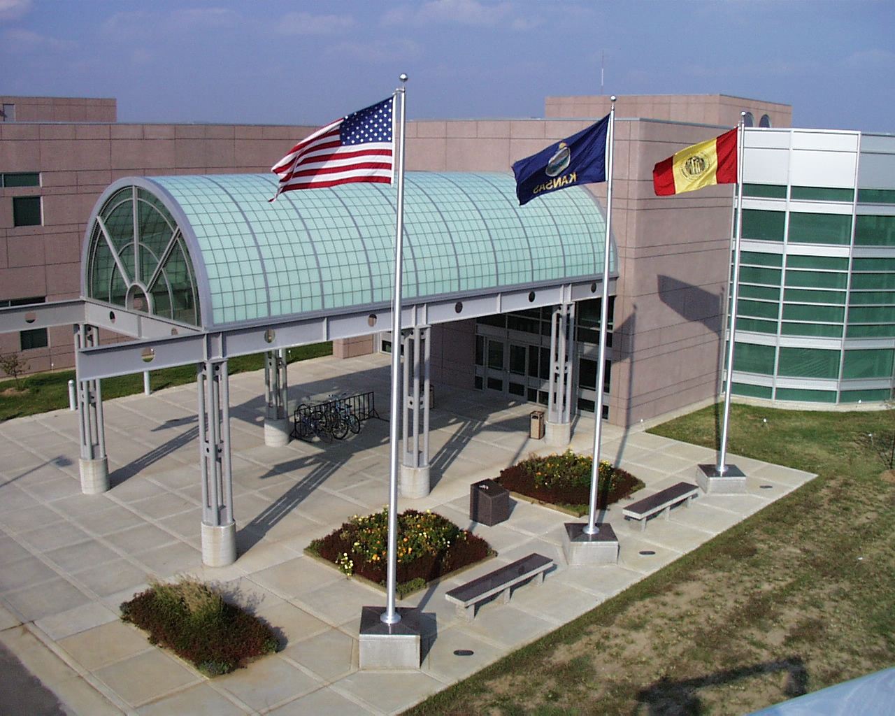

College of Technology

Virtual Open House and

Career Expo

Lesson Plan: College of Technology Virtual Open House and Career Expo
I. Objective:
Provide students an opportunity to investigate technology-related careers through a virtual open house experience.
II. Preparation
Purpose
The purpose of this lesson is to provide students an opportunity, through a virtual open house and career expo, to virtually investigate in depth a variety of undergraduate technology-related program majors, including program overviews and emphases, student perceptions, laboratory facilities and equipment, related processes and experiences, student organization, and career opportunities. Additionally, students can learn about careers in technology, scholarship opportunities, military scholarships and activities, completion degree programs, and general information about a regional, comprehensive university.

Website and Instructional Materials/Equipment
Teacher – The following are required for teaching this lesson:
- Computer with internet access
- Projection system (optional but recommended)
- Website: https://www.pittstate.edu/technology/events/college-of-technology-open-house.html
Review of “Best Practices and Perspectives”
Review of entire website prior to presenting lesson to students
[Note: Be sure to thoroughly preview Activity I- Welcome & Overview, including related feedback sheet; and view the program most closely related to what you teach in Activity II and related feedback sheet.]

- Interactive Feedback Sheets:
- Virtual Open House Overview Feedback Sheet
- Virtual Open House Program Feedback Sheet(s) - series of 14 different programs
- Virtual Open House Information Station Feedback Sheet
Students – The following are required for students for this lesson:
- Computer with internet access
- Website: https://www.pittstate.edu/technology/events/college-of-technology-open-house.html
3. Interactive Feedback Sheets:
- Virtual Open House Overview Feedback Sheet
- Virtual Open House Program Feedback Sheet(s) - series of 14 different programs
- Virtual Open House Information Station Feedback Sheet
III. Procedure
A. Anticipatory Set
Set the stage for using the Virtual College of Technology Open House and Career Expo as a lesson by relating to them--- the need to investigate careers to make informed decisions. Many students will soon invest four or more years of their lives and thousands of dollars in pursuing a degree at a college and ultimately a career, without sufficient investigation beforehand. For example, what are the job prospects and job outlook following graduation? This lesson will allow students to virtually explore and investigate 14 different undergraduate technology-related program majors, including program overviews and emphases, student perceptions, laboratory facilities and equipment, related processes and experiences, student organization, and career opportunities. Additionally, students can learn about careers in technology, scholarship opportunities, military scholarships and activities, completion degree programs, and general information about a regional, comprehensive university. This lesson prepares students to make more informed decisions regarding careers.
Prior to class-- Have the Virtual Open House (VOH) website loaded on presentation computer and projected on screen.
B. Lesson Outline and Instructions
The College of Technology Virtual Open House and Career Expo has four major components. Today, the focus will be on Activity 1 Overview, and Activity 2 Program Investigation. Activity 3 Information Station may be done in class or done as an outside assignment. Activity 4. Wrap-up-Ideas, Rewards (Door Prizes/Scholarship Vouchers) and Next Steps will be done on a future date per instructions on the website.
1. Outline
Activity 1. Welcome, Overview and Instruction
Step 1: Set the stage for today’s lesson by sharing information noted under anticipatory set.
Step 2: Instruct students to go to the virtual open house website-landing page: https://www.pittstate.edu/technology/events/college-of-technology-open-house.html You may want to provide link electronically to them.

Step 3: Instruct students to click on “Activity I – Welcome, Overview, Instructions” and view the videos together as a class.

Step 4: As a class, have students click on and complete the “Virtual Open House Overview Feedback Sheet”.

Step 5: Each student completes the “Virtual Open House Overview Feedback Sheet” and submits it.

Activity 2. Investigate--Program Demonstrations and Information Sessions

Step 1: Explain to students that this class will investigate a program together following the instructions discussed in Activity I. Since we are in ___ class, we will investigate the ____ Program, which is most closely related to this class.
[Note: A few examples include: Ag Mechanics .>>Automotive Technology; Automotive >> Automotive and/or Automotive Service; Chemistry>>Plastics Engineering Technology and /or Environmental Safety Management; Art >> Graphics Communication or Interior Design; Building Trades >> Construction Management or Electrical Technology; Physics >> Electronics Engineering Technology or Mechanical Engineering Technology; Welding or Machining >> Manufacturing Engineering Technology; Videography or Speech>> Communication-Media Production or Graphic Communication; Wood Technology or Cabinetmaking >> Wood Product Manufacturing; any technology area or technology & engineering education class>> Technology and Engineering Education and or Environmental Safety Management]
Step 2: Instruct students to go to Activity 2 and click on the program previously noted for the class to do together. Have the students click on “Step1 - Investigate”, and then click on “Step 2- Complete Feedback Sheet” for this program. Explain that they will be able to toggle between the links as they investigate the program and answer questions.

Step 3: View the “Program Overview” as a class.

Step 4: Have students view the “Overview” video and toggle to “feedback Sheet” and complete questions #1-3, on the program feedback sheet.

Step 5: Instruct the students to listen carefully to the student as they share his or her perceptions. Have students view “Student Perspective” and answer question #4 on the feedback sheet.

Step 6: View “Lab Overview” and answer questions #5-6 on the feedback sheet.

Step 7: View all “Demonstration/Information Sessions” and answer questions #7-8 on the feedback sheet.

Step 8: View “Student Organization” and answer questions #9-10 on the feedback sheet.
Step 10: View “Alumnus/Corporate Career Minute” and answer questions #11-12 on the feedback sheet.
Step 11: View info related to “Wrap-Up—Awards, Rewards (Door Prizes) and Next Steps, and answer questions #13-14 on the feedback sheet.
Step 12: Complete #15 - RATING Your Interest (including filling in name, instructor name, and instructor email address), and each student submit “Virtual Open House ___ Program Feedback Sheet to instructor. [Note: Again, properly completed feedback sheet with instructors’ information is “ticket” for door prizes, as well as determining award recipients.]

Step 13. Students begin to complete investigations of a minimum of four (4) additional programs following Step #3-12 above.

Step 14. Note Future and Follow-up Activities-- [“See D. Follow-up Activities” and “Wrap-up” information below.

C. Closure/Summary
Summarize today’s activity (may want to refer to the “Purpose” under Anticipatory Set.). Ask students questions about the program investigated as a class and have them share key points of interest to them.
D. Follow-up Activity (Outside Class or next class period) – Continue Activity 2 and Activity 3- Information Station

1. Students may use another class period to complete “Activity 2- Program Investigations” and investigate additional program areas. An alternative to doing the four additional programs in class is to do investigations outside of class. Additional investigations, beyond a minimum of four, could be done for extra credit.
- View each topic in Activity 3. “Information Station” and toggle to “Information Station Feedback Sheet” and answer questions.

Wrap-Up –Awards, Rewards (Door Prizes) and Next Steps

Awards. Feedback Sheet Data for Fall 2023 and Spring 2024 COT Open Houses will be compiled after March 9, 2024. Information regarding recipients of scholarships and door prizes should be accessible on the website the following week. Next Steps. Future events, tour opportunities, additional informational websites, etc. will also be posted during the Fall and Spring semesters.
E. Evaluation

Feedback sheets submitted can serve as a formative evaluation activity. Questions about the investigation process and content could be incorporated in a more comprehensive, summative course evaluation.

