Pittsburg State University
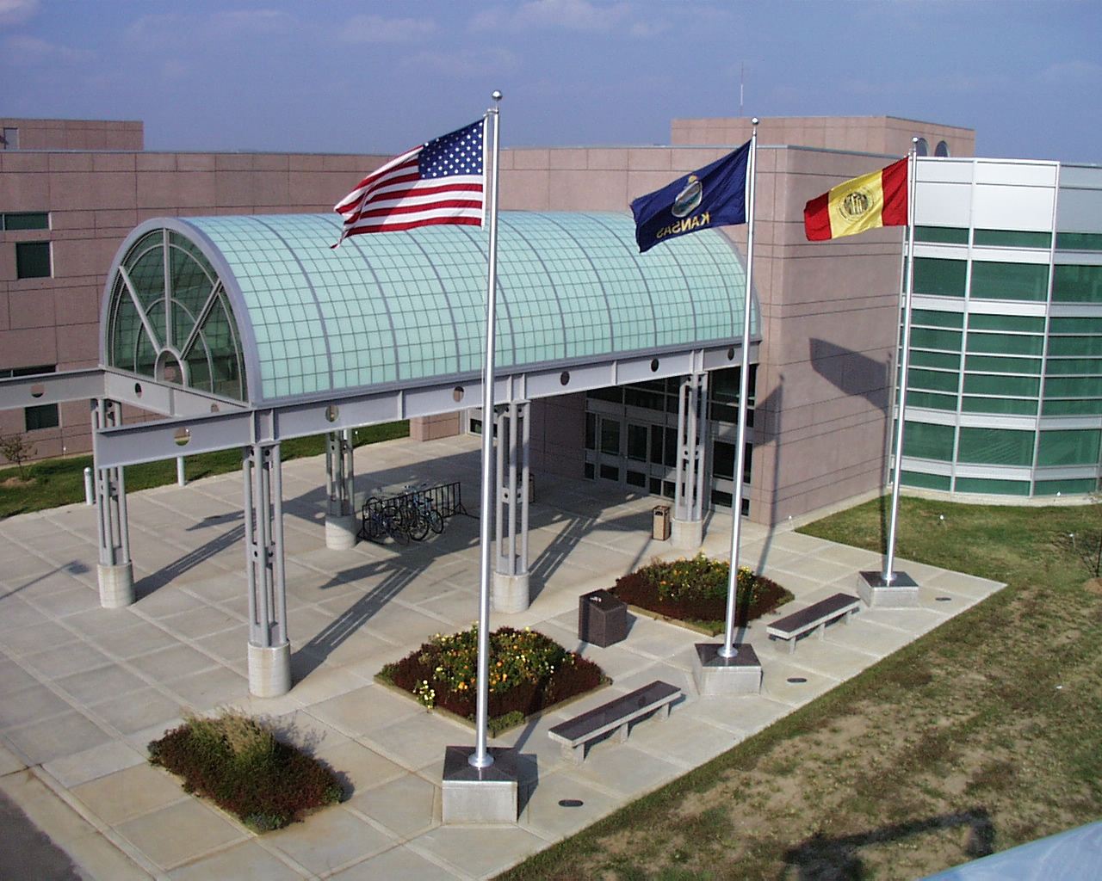

College of Technology

Kansas Technology Center

Open House and Career Expo

Activity Sheet: Pre-Event Exploration Total Points Possible: ____/50

Name: _____________________________________

Friday, March 1st, 2024 8:00 a.m. – Noon, 12:00 p.m.
Registration is required. Register at: Open House Registration
Use the same link to obtain more information about the COT Open House.

Scenario: You are planning to attend the KTC Open House to experience activities associated with Pittsburg State University’s College of Technology programs. You will have a limited amount of time to check out dozens of demonstrations and interact with program majors and faculty for 12 +different program areas. To make the best use of your time, you plan to check out the College of Technology and investigate programs ahead of time. You will determine which programs to check out first. Then, you’ll check out other program areas.

Resources: | - Access Code/Link to Virtual Open House Site provided in email after Registering.
 | - Device and internet access to explore Virtual Open House website

General 1) Access the College of Technology Virtual Open House site using the access provided to
Directions: you from PSU (open now until March 8, 2024)
2) Follow the specific directions noted under Activity 1 & 2 below.

Activity 1. Welcome and Overview to College of Technology (10 Total Points) .

Directions: 3) Click on Virtual Open House Activity 1, then view videos and read text associated with Activity 1.
4) Complete Activity 1 [SUBMIT] Feedback Sheet and submit it. (Note: Quality, complete, feedback sheet you submit serves as your ticket in a drawing for door prizes and scholarship vouchers.)
5) After completing the previous steps, answer the following questions and click on Go to Activity 2.

What type of program(s) do you want to investigate? _______________________________________2 pts.
What additional information do you hope to gain by attending open house and career expo?
__________________________________________________________________________________ 4 pts.
As of now, what program interests you the most? ___________________________________________ 2 pts.
As of now, what lab or activity are you most interested in seeing? _____________________________ 2 pts.

Activity 2. Investigate—Program Demonstrations and Info Sessions (30 Total Points)) .

Directions: 6) Select 1 of the 14 program areas (e.g., Graphics Communication) and click on Investigate.
7) For STEP 1-INVESTIGATE, view Overview (video and/or text) associated with program.
8) then click on STEP 2-COMPLETE FEEDBACK SHEET (top of page). Open feedback sheet and answer questions related to “Overview”.
9) Repeat steps 7 & 8 for remaining sections, then submit Feedback Sheet (door prize ticket).
10) After completing 6-9, answer the following question below for Program #1 you just investigated, then repeat steps 6-10 for Program #2 and Program #3.
Program #1 (10 points)
Program Name: ___________________________________________________________________________1 pt.
Name of Degree: __________________________________________________________________________2pts.
Emphasis of Interest (if applicable): ___________________________________________________________1 pt.
Point of interest You Discovered: _____________________________________________________________2 pts.
Question(s) for Faculty Member: _____________________________________________________________
________________________________________________________________________________________2pts.
Question(s) for Student in Major: ____________________________________________________________
________________________________________________________________________________________2pts.

Program #2 (10 points)
Program Name: ___________________________________________________________________________1 pt.
Name of Degree: __________________________________________________________________________2pts.
Emphasis of Interest (if applicable): ___________________________________________________________1 pt.
Point of interest You Discovered: _____________________________________________________________2 pts.
Question(s) for Faculty Member: _____________________________________________________________
________________________________________________________________________________________2pts.
Question(s) for Student in Major: ____________________________________________________________
________________________________________________________________________________________2pts.

Program #3 (10 points)
Program Name: ___________________________________________________________________________1 pt.
Name of Degree: __________________________________________________________________________2pts.
Emphasis of Interest (if applicable): ___________________________________________________________1 pt.
Point of interest You Discovered: _____________________________________________________________2 pts.
Question(s) for Faculty Member: _____________________________________________________________
________________________________________________________________________________________2pts.
Question(s) for Student in Major: ____________________________________________________________
________________________________________________________________________________________2pts.

Top Priority to Visit at KTC Open House (10 Total Points) .
1st Choice to Visit: __________________________________ (4 pts.)
2nd Choice to Visit: __________________________________ (3 pts.)
3rd Choice to Visit: __________________________________ (3 pts.)
[Note: If you completed (in a quality manner) and submitted four (4) “Feedback Sheets,” you now have four (4 of 16 possible) “tickets” entered to possibly win possible door prizes or scholarships.

“Information Station” and other “Investigate” Programs have feedback sheets that provide additional opportunities to win possible door prizes and win scholarship vouchers, if interested.]

