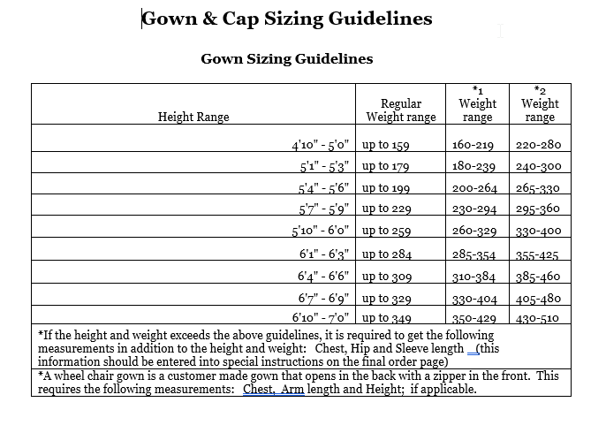
If measurements are outside of the above ranges, please contact the bookstore at 620-235-4875.

