Paper Title in Bold: Capitalized in Title Case

Student Name
Department of Something Interesting, Pittsburg State University
IDN 311: Course Title
Professor M. Staff
March 2, 2024

Paper Title in Bold: Capitalized in Title Case
The introduction starts here. In APA format, the introduction doesn’t get a section header. This sentence was just added to make it easier to see that the first line of the paragraph is indented .5 inch.
First Level Header
Use section headers to help readers navigate your paper. APA has five levels of headers, but you don’t need to try to use them all. Use as many levels as you need to show the major divisions in your content and to show content that is nested within sections. Use first level headers to identify your paper’s major divisions, but also remember that not every paper needs headings. The basic rule is that at every level (first, second, etc), headings should always come in sets of at least two. If you only need one heading, then you don’t need any headings.
Second Level Header: At the Left Margin
Notice that APA does not add extra line-spacing between paragraphs or before or after the title or section headers. In APA format, paper content is double-spaced from the beginning of the title page to the end of the references list, with no extra space before or after paragraphs or before or after the title or section headers.
Third Level Header: At the Left Margin and Italic
This is just a bunch of filler content to show what the beginning of the section would look like. The rest of the content in this section will be filler, so skip to part 2, “The Second Major Section of This Paper.”
Fourth Level Header: Indented .5 Inch from the Left Margin
This is just a bunch of filler content to show what the beginning of the section would look like. And here’s even more filler. Thank you for reading it. I bet you also watch the credits at the ends of movies, don’t you? If I were a gaffer or the best boy I would be so glad to know that there are people like you in the audience!
Fifth Level Header: Indented .5 Inch from the Left Margin and Italic
Oh, thank goodness! We’ve finally arrived at the fifth and final level of heading. The next section is the second major division of the paper and introduces a new top-level topic.
The Second Major Section of This Paper
This section illustrates basic formatting for tables and figures and for short and long quotes.
Tables and Figures
Each table or figure should have a numbered label (Figure 1, Table 1) in bold at the left margin, followed by its title (capitalized in title case) in italics, at the left margin. A caption following the table or figure can be used to include additional information and copyright attribution. The caption begins with the word “note” in italics. Here is an example (see Figure 1).
Figure 1
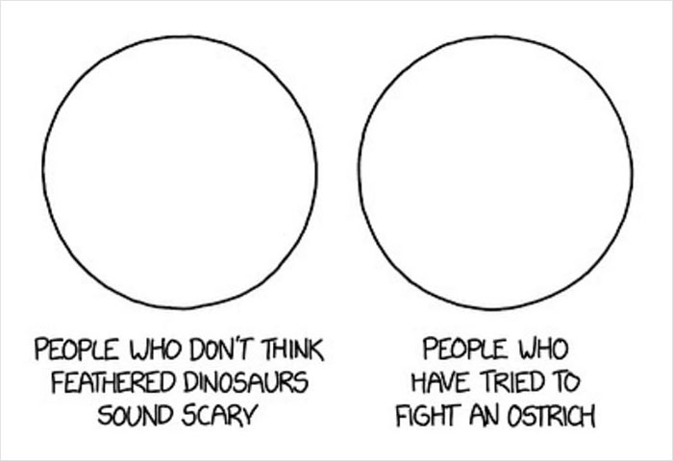
Venn Diagram Representing Your Content in an Informative Way

Note. I actually think this diagram is very useful, even though the source apparently doesn’t think so. From “People Are Cracking Up at These 31 Venn Diagrams That Are More Funny Than Useful,” by J. Dominauskaite and S. Tolstych, 2023, BoredPanda (https://www.boredpanda.com/venn-diagram-meme). Copyright ParallelParkingInABurka.
The body of the paper restarts here. I know this is confusing because it feels as though there should be extra space between the end of the note for Figure 1 and the return to the main text. If this makes you very uncomfortable, I think you could probably sneak in an extra single-spaced line below the note.
One more thing you should notice about figures and tables is that they carry their citation information with them in the note, so the source for this figure is not in the references list. And finally, the rule about double-spacing all content doesn’t apply to the content contained in figures and notes. That means that within figures and tables you should select font, type size, type style, line-spacing, and text alignment based on what will make your content visually appealing and easy to understand.
Quoting, Paraphrasing, and Citing Sources in APA
A quote is when you use ideas or information from a source in the source’s exact words. A paraphrase is when you use ideas or information from a source but restated in your own words. Both types of borrowed content must be cited; however, this document is specifically about format, not about principles of good writing, so I’m going to skip over most of what you need to know about how, when, and why to use source material in your writing and go directly to how to format quotes.
The first rule of quotes is that you should quote as little as possible. The second rule is that all quotes should be “built into a longer sentence of your own” (Bigger & Green, 2017, p. 289). The third rule, illustrated in the parenthetical citation in the previous sentence, is that in-text citations for quoted material need a page number if the document has page numbers.
Here’s another example of a short quote. Horemheb and colleagues (1294 B.C.) found that “long distance relationships were more challenging for participants who did not enjoy traveling” (p. 37). Notice that this time the author is used as the subject of the sentence. In APA, the date stays with the author, so the parenthetical citation after the quote includes only the page number. Also notice that there is no punctuation before the parenthetical citation. The closing punctuation goes after the parenthetical citation.
For quotes of 40 words or longer, use a block quote. In a block quote, each line of the quoted material should be indented .5 inch from the left margin, quotation marks are not used, and the final punctuation (the period at the end of the sentence) appears before the parenthetical citation instead of after it. Here’s what that would look like.
Horemheb et al. (1294 B.C.) found that:
Long distance relationships were more challenging for participants who did not enjoy traveling, and those participants also experienced more stress in relation to holidays, particularly the Great Festival and the Opening of the Year festival, which often require more travel than other holidays in order to celebrate with family. (p.23)
After a block quote, be sure to come back take control of the paragraph in your own voice again. The block quote is a moment when you let someone else (the author of the quote) take control of your paper. If you don’t come back afterward to re-establish yourself as the boss of your paper, your readers are likely to struggle to understand your argument.
Bigger and Green (2017) and Small (2015) explain that in APA format, sources are identified by author and year of publication in both in-text citations and in the references list. However, sources with three or more authors are shown with only the first author’s name and “et al.” (the Latin abbreviation for “and others”) in parenthetical citations (Green et al., 2019). Green and colleagues (2019) note that when the author’s name is stated in the body of your text, as it is in this sentence, then “et al.” can be replaced with an ordinary language equivalent, like “and colleagues” or “and group.” For sources with up to 20 authors, all authors are listed in the references list entry (McAdoo, 2019).
When writing in APA style, writers should use quotations sparingly (APA, 2020) and instead rewrite ideas and information from sources in their own words. When quoting, always “build the quoted material into a sentence of your own” (Bigger & Green, 2017, p. 289), and immediately indicate the source of the quoted material using an in-text citation, even if it is not the end of a sentence. Bigger and Green (2017) also note that when the author’s name is stated in the body of your text, as it is in this sentence, then “the parenthetical citation is divided” (p. 293), with the date appearing immediately after the author’s name and the page number immediately following the quoted material. According to Small (2015), the page number always stays with the quoted material, whether the author’s name appears in an attribution phrase or in the parenthetical citation. And finally, when citing multiple sources in a single citation, list the sources in alphabetical order (Bigger & Green, 2017; Bigger & Smaller, 2018; Green, et al., 2019; Small, 2015).
Conclusion
The next page has a sample references list of fake sources designed to show how to cite common types of sources.

References
Bigger, A. B., & Green, H. (2017). A fake journal article with two authors: And a doi number. Journal of Academic Publication Styles, 10(3), 287-301. https://doi.org/10.1080/03055690903424790
Bigger, A. B., & Smaller. M. N. (2018). A fake book with a short title. Rowman and Littlefield.
Centers for Disease Control and Prevention. (n.d.-a). Citations twins: The first of two sources with the same author and date. U.S. Department of Health & Human Services. Retrieved June 13, 2023, from https://www.cdc.gov/diabetes/prevent-type-2/index.html
Centers for Disease Control and Prevention. (n.d.-b.). The second of two citation twins. U.S. Department of Health & Human Services. Retrieved June 13, 2023, from, https://www.cdc.gov/diabetes/basics/type2.html
Green, H., Bigger, A. B., & Smaller M. N. (2019, June 4). A fake article from a website. http://www.universityworldnews.com /article.php?story=20111118150938606
Horemheb, K., Akhenaten, K, & Tutankhamun, K. (Hosts). (1294 B.C.-present). Nile Notations: An Eternity of Pharaohs [Audio podcast]. National Public Radio. https://www.npr.org/podcasts/510312/eternity_of_pharaohs
National Library of Medicine. (n.d.). A different source with an organization as author and no date. U.S. Department of Health and Human Services, National Institutes of Health. Retrieved October 3, 2022, from https://medlineplus.gov/ency/patientinstructions/000473.htm
Small, R. W. (2015). A fake chapter in an edited book. In H. Green & A. B. Bigger (Eds.), A fake edited book (pp. 35-52). John Wiley and Sons.

