USING NOTIFICATIONS IN GUS CLOUD
Approval Notifications Bell Best Practices

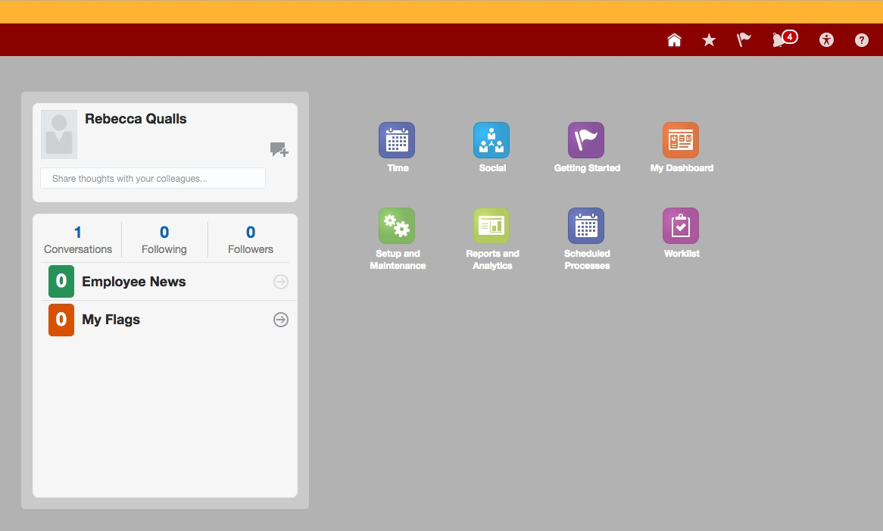
Anytime there is an expense approval needed (travel expenses for all of campus/line managers for approving expenses, purchases and time cards), clients will receive both an email and a notification in GUS Cloud. Approvals/rejections can be done directly from the email, but the notification will still appear on the GUS Cloud Notification on the GUS Cloud Springboard.
A badge will appear on the bell Notification icon on the top right of the springboard indicating how many notifications appear under this menu. This is not necessarily an accurate listing of the notifications that a client has.
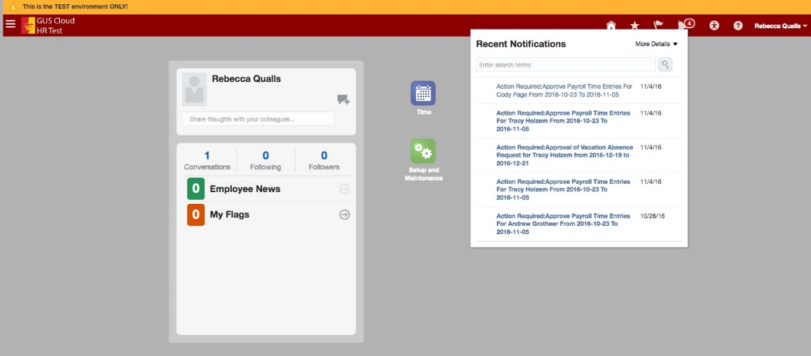
Clicking on the bell will open a drop down list of the notifications currently housed under that notification icon; however, if you have approved or rejected an expense item from an email you received this will not remove the notification from this list. Selecting any notification on this list will take to you to the approval/rejection screen within GUS Cloud to complete the approval. Even after you complete this step the approval will not disappear from this drop

down list. These approval notices go away only after a period of time has passed even if action has already been taken.

The best way to handle notifications in GUS Cloud is to go to the Worklist.
This will open the worklist window that has approval tabs for Financials, Human Capital Management (HR), and Procurement.
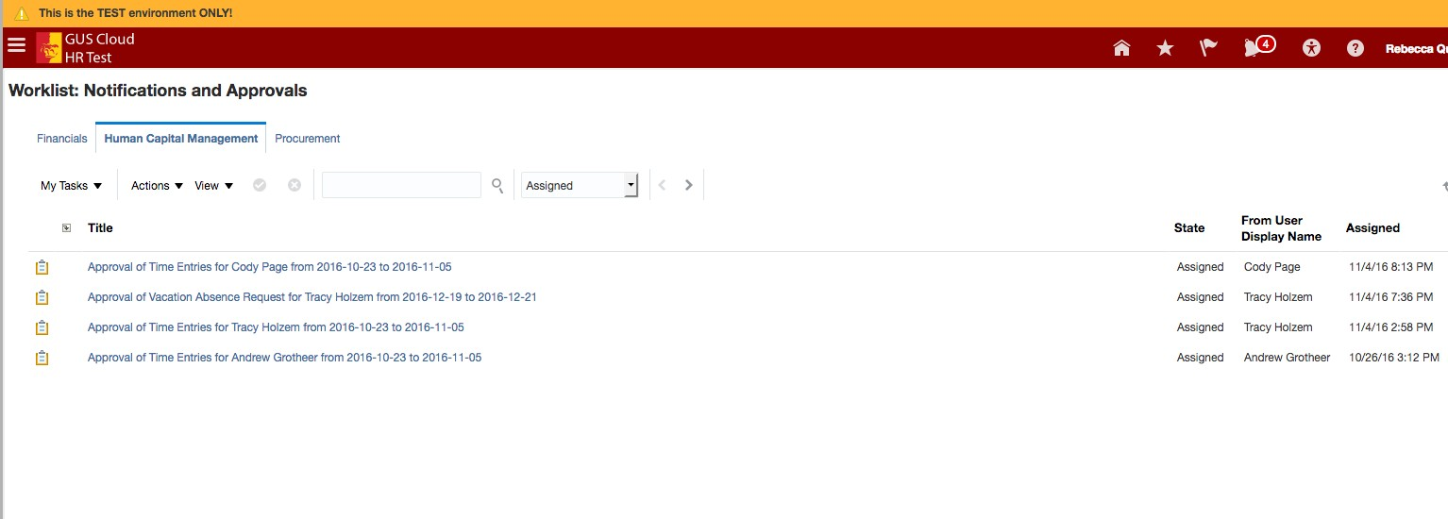
Approval Tabs

Approvals for Expenses (any employee who travels will have to approve his/her travel expenses even if you have delegated someone else to enter them for you) will always be found under the Financials tab. Clicking on the name of the approval will take you to the screen that will allow you to approve or reject the item. Even after completing this action, the notification icon (bell) on the springboard will still contain the dropdown list with this approval listed. If the Worklist screen is empty, you have completed approvals for all required transactions.

