Customer Complaint:
The vehicle’s horns stay on continuously. The owner thinks the horn relay may be stuck in the on position. Specifically describe how you would test the horn relay in this case. Additionally, besides the horn relay, describe three more circuit faults that would cause the horns to remain on. Indicate specifically how you would test for each fault and the action needed to correct each problem.
1999 Plymouth Prowler Horn Circuit
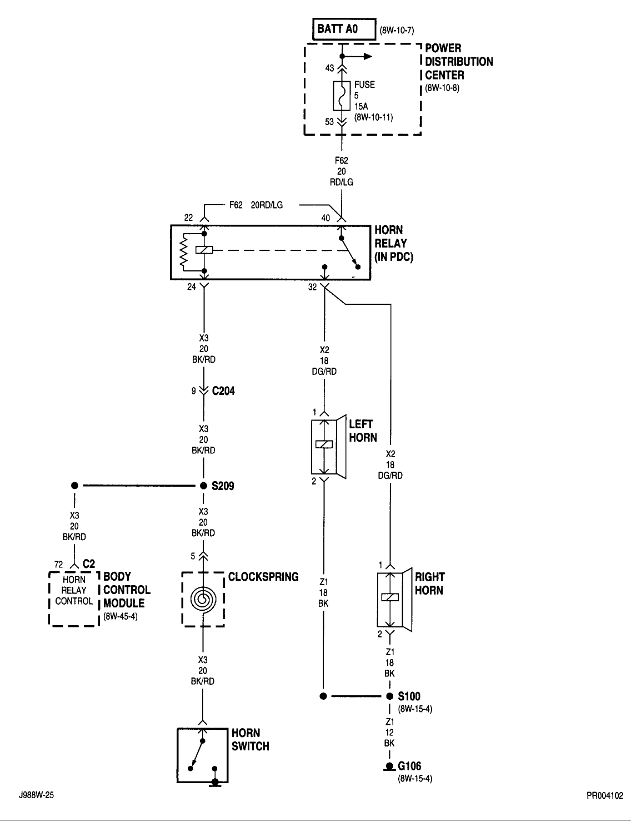
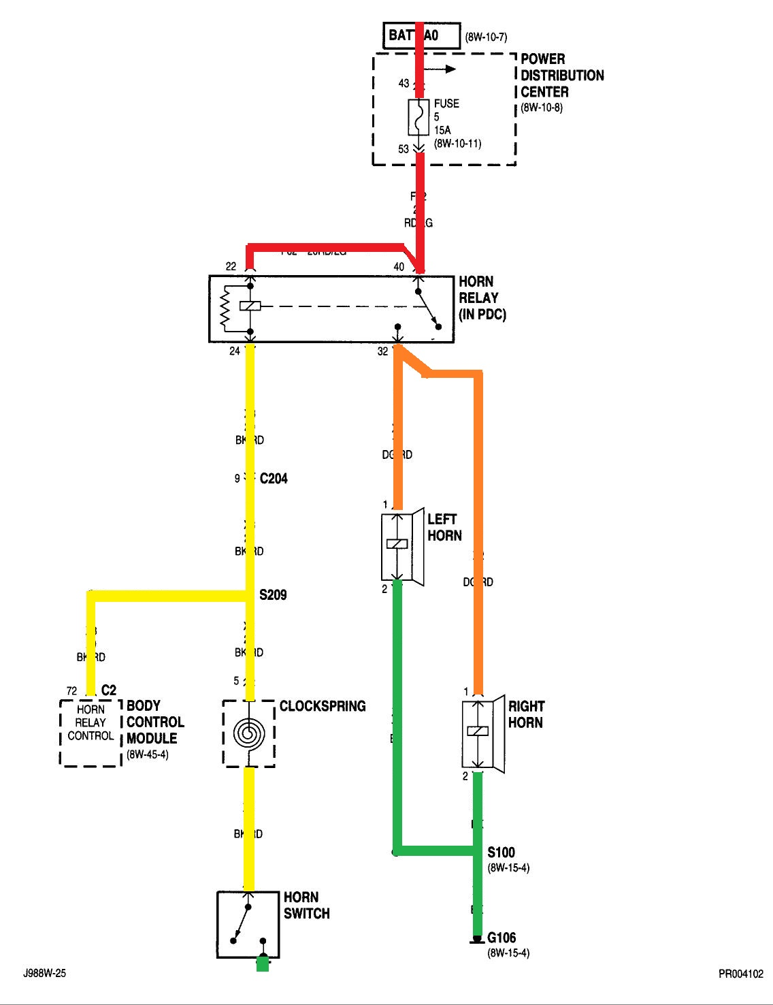

Possible Circuit Problems
Horn switch shorted to ground
Clockspring shorted to ground
Body Control Module
Shorted to ground
Commanding horns on due to inputs
Relay BK/RD control wire grounded between pin 24 & Clockspring pin 5
Horn DG/RD power wire shorted to power

