Accessibility and Course Design
Best Practices for Canvas and Microsoft Office

spring 2019
center for teaching, learning & technology
Pittsburg State University

Contents
Accessibility Overview & Objectives 2
Objectives 2
Creating Accessible Course Content 2
Hyperlinks 2
Do's and Don'ts of Creating Hyperlinks 2
Additional Resources 3
Tables 3
Data Tables in Canvas 3
Additional Notes 5
Formatting Headings (Titles and Subtitles) 5
Canvas Heading Styles 5
Microsoft Word Heading Styles 5
Formatting Lists 6
Canvas Lists 6
Microsoft Word and PowerPoint 6
Accessibility and Privacy Statements for Students 6
Accessibility Information and VPAT’s 6
Privacy Policies 7
Accessibility of Images and Multimedia 8
Alternate Text for Images 8
Alternate Text Example 8
Applying Alt Text in Canvas 8
Applying Alt Text in MS Word and PowerPoint 9
Closed-Captioning and Transcripts for Video and Audio 9
Faculty Created Videos 10
YouTube and Other 3rd-Party Videos 10
Audio Files 10
Recommended Design Practices 10
Font Styles and Size 10
Font Types 10
Font Size 10
White Space, Color and Contrast 11
White Space 11
Color 11
Contrast 11
Sizing Images and Length of Videos 12
Images 12
Video 12
Testing on Different Devices/Screens 12
Images in Canvas Mobile App 13

Accessibility Overview & Objectives
This document discusses ways to create content that is accessible for all students as well as design recommendations to enhance the readability of your course. Quality Matters standard 8 is all about accessibility and usability. This module will help you work towards meeting these standards.

Objectives
After reviewing this document, you will be able to...
- Identify methods for creating hyperlinks, tables and text headings that facilitates ease of use in navigating your course.
- Include an accessibility statement for all technologies used in your course to share with your students.
- Apply alternate text to images and evaluate the need for closed-captioning and/or text transcripts for audio or video.
- Apply best practices for design to increase usability of your course including formatting for text, color and contrast, image and video size as well as how to test these elements on multiple devices and screen sizes.

Creating Accessible Course Content

Hyperlinks
When linking to files or web pages, avoid the typical "Click Here" link text. Instead, the hyperlink text should describe what the student will be opening. This not only helps students who may be using a screen reader, but it also increases student confidence in finding the content.
There are two parts to a hyperlink--the link text and the actual URL address.
- Link Text YouTube
- Actual URL address https://www.youtube.com/

Do's and Don'ts of Creating Hyperlinks
- Do not include the word "link" in the link text.
- Do NOT use "click here" or "click for details" as your link text.
- Link text should describe the link destination.
- Add additional information about the link after the link text.
  - Syllabus (Word Document)
  - Autism Video (Opens in a new window)

Additional Resources
- Links and Hypertext (WebAIM)
- Guidelines for In-Text Links (Accessbility and Usability at Penn State)

Tables
Create tables in Canvas to organize data. If you want to use a table to control the layout of text and/or images on your page, please consult the Creating Accessible Tables from WebAIM. It is best not to use a table to control the layout of your page if possible.

Data Tables in Canvas
Creating accessible tables in Canvas is possible using the table tool from the Rich Content Editor. Below is a basic example of an accessible Canvas table.
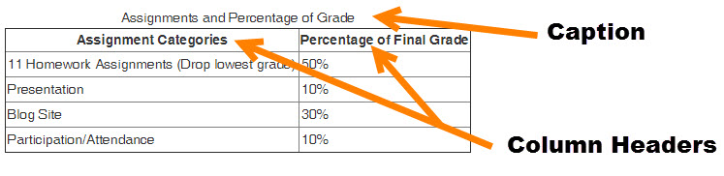

Insert Table Caption
- Follow the Canvas-provided instructions on how to insert a table in Canvas
- Highlight the table.
- Click the Table insertion tool to reveal the menu.
- Select Table Properties in the menu.
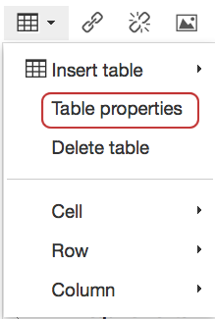
- Check the option for Caption on the General tab, then click OK.
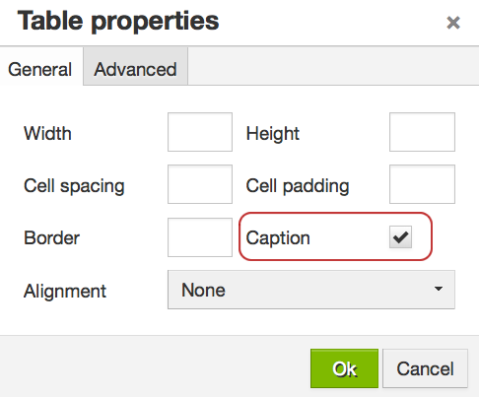
- A slot to enter a table title (caption) will appear in the Rich Content Editor.

Set Cell Properties to Headers
By default Canvas tables do not include headers, but you can change the top row or the left column to headers in the Cell Properties option.
- In a table highlight, the cells of the first row.
- Click the Table insertion tool to reveal the menu.
- Select Cell : Cell Properties in the menu.
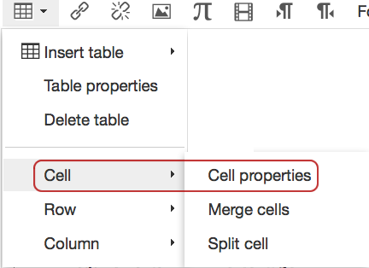
- In the Cell Properties window, change the Cell Type to "Header Cell."
- Set the Scope to "Column." Click OK to save the settings.
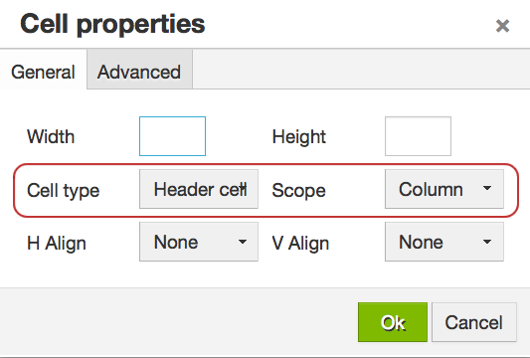

Additional Notes
Avoid merging cells as this can disorient a screen reader. If you have row headers, you can also apply those settings, just set the "scope" to Row.

Formatting Headings (Titles and Subtitles)
Headings and subheadings are used in long documents and books to help guide readers. Content created in Word or with the Canvas Rich Content Editor (RCE) should use the styles tool for each to apply these headings. (This paragraph uses the "Paragraph" style format.)

Canvas Heading Styles
The last option on the RCE is a styles tool that offers these options:
- Paragraph - Use for general narrative.
- Header 2 - Use for headlines such as shown above
- Header 3 - Use to separate sections of content applicable to Heading 2
- Header 4 - Use for sub-sections for Heading 3 content.
- Preformatted

Additional Considerations
Do NOT use font sizes on the RCE to create headings. Apply the header style. Use the Headers in descending order. For example:
- Start with Header 2,
- then, apply Header 3 if appropriate for your content,
- then, apply Header 4 if appropriate for your content.

Microsoft Word Heading Styles
In Word, there is a Styles tool located on the Home tab. These settings help you create an accessible Word document. Below is a screenshot of a Word document using the Title style as well as Headings 1, 2 and 3.
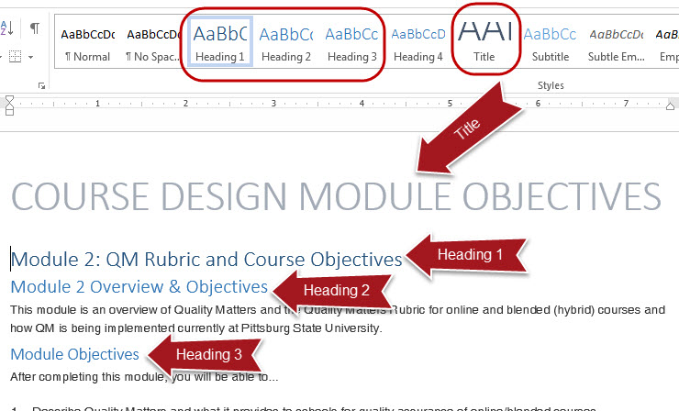

Formatting Lists
If you create a numbered or a bulleted list, use the tools in the Canvas Rich Content Editor (RCE) or in Microsoft Word and PowerPoint to style these lists. Do not enter the numbers or bullets from your keyboard. By using built-in tools to create these lists, you are creating a course item that is accessible for those using screen readers.

Canvas Lists
To create a numbered or bulleted- list in Canvas, select the appropriate tool from the RCE. Click the Bulleted List icon to make bulleted list [1]. Click the Numbered List icon to make a numbered list [2].
Enter the text for your list item and use the Enter key to move to the next item. To remove the number or bullet, highlight the row where you'd like to remove the formatting and click the corresponding icon again.
This functionality is available anywhere you have the RCE in Canvas--Announcements, Assignments, Discussions, Pages, Quizzes and the Syllabus.

Microsoft Word and PowerPoint
Follow the same process in Word and PowerPoint to have the software create your bullets or numbering for a list. In Word and PowerPoint, the tools are found on the Home tab in the Paragraph group
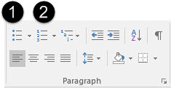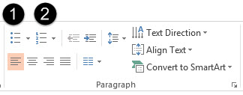
Try not to leave extra bullets or numbers at the end of your lists. Remove by selecting the line next to the item and click on the corresponding toolbar icon again.

Accessibility and Privacy Statements for Students
Including statements for the accessibility of all tools used in your course helps meet QM standards 8.6. Accessibility statements help students who may need accommodations determine if resources will be usable for them. Additionally, including links to privacy policies is also a good practice and is recommended in QM standard 6.4.
Canvas provides an accessibility statement for their product. Many web applications provide a Voluntary Product Accessibility Template (VPAT.) A link to the Canvas Voluntary Product Accessibility Template should be included in your online/hybrid course.
Below is a list of common third-party tools used in online courses at Pittsburg State. Links to Accessibility and Privacy statements are included if available.

Accessibility Information and VPAT’s
Below are links to accessibility policies for commonly used third-party tools at Pittsburg State. Hyperlinks are typed out to accommodate a printed version of this information.
Product | Accessibility Information | VPAT if available
Adobe Products | http://www.adobe.com/accessibility.html | http://www.adobe.com/accessibility/compliance.html
Apple | http://www.apple.com/accessibility/ | https://support.apple.com/accessibility/vpat
Big Blue Button | http://bigbluebutton.org/accessibility/ | https://bigbluebutton.org/files/vpat.pdf
Canvas | https://www.canvaslms.com/accessibility | Included in Accessibility Information
Facebook | https://www.facebook.com/help/141636465971794/
Google | https://www.google.com/accessibility/
McGraw-Hill Connect | http://createwp.customer.mheducation.com/wordpress-mu/success-academy/accessibility/
MacMillan Education LaunchPad | http://www.macmillanlearning.com/Catalog/other/accessibility
Microsoft Products | https://www.microsoft.com/enable/ | https://www.microsoft.com/en-us/download/details.aspx?id=13758
Pearson Education | http://www.pearsonhighered.com/educator/accessibility/index.page
Qualtrics | http://www.qualtrics.com/university/researchsuite/advanced-building/advanced-options-drop-down/check-survey-accessibility/
Respondus Products | http://www.respondus.com/products/accessibility-lockdown.shtml | http://www.respondus.com/products/accessibility-lockdown.shtml
Screencast-O-Matic | Not available
Turnitin | http://turnitin.com/en_us/about-us/accessibility
VidGrid | Not available | Closed captioning is available in the platform
YouTube | https://support.google.com/youtube/topic/6091042?hl=en&ref_topic=6091039
Zoom | https://zoom.us/accessibility | Included in Accessibility Information

Privacy Policies
Below are links to privacy policies for commonly used third-party tools at Pittsburg State. Hyperlinks are typed out to accommodate a printed version of this information.
Product | Privacy Policy
Adobe Products | http://www.adobe.com/privacy/policy.html
Apple | http://www.apple.com/privacy/privacy-policy/
Big Blue Button | See Canvas policy for Pitt State implementation
Canvas | https://www.canvaslms.com/policies/privacy
Edpuzzle | https://edpuzzle.com/privacy
Facebook | https://www.facebook.com/policy.php
Google | https://www.google.com/policies/privacy/
McGraw-Hill Connect | http://connect.customer.mheducation.com/privacy/
MacMillan Education LaunchPad | http://www.macmillanlearning.com/Catalog/content.aspx?Title=136
Microsoft Products | https://privacy.microsoft.com/en-us/privacystatement/
Pearson Education | http://www.pearsoned.com/privacy-statement/
Prezi | https://prezi.com/privacy-policy/
Qualtrics | http://www.qualtrics.com/privacy-statement/
Respondus Products | https://www.respondus.com/about/privacy.shtml
Screencast-O-Matic | https://screencast-o-matic.com/privacy
Turnitin | http://turnitin.com/en_us/about-us/privacy
Twitter | https://twitter.com/privacy?lang=en
VidGrid | https://www.vidgrid.com/privacy/
YouTube | https://www.youtube.com/static?&template=privacy_guidelines
Zoom | https://zoom.us/privacy/

Accessibility of Images and Multimedia

Alternate Text for Images
Students who have visual impairments may need to use a screen reader. All images used in your course and/or in PowerPoint and Word should have Alternate text applied to them. This is "hidden" text that describes the image so that the screen reader can convey the meaning to its listener. This helps meet an essential standard 8.3 on the QM rubric.

Alternate Text Example
Alternate text should be descriptive. For the image below, appropriate alternate text would be, "one boy and two girls sitting on a couch with a smartphone, tablet, and laptop."

Applying Alt Text in Canvas
When adding an image to Canvas, it will automatically inherit the name of the file with the file extensive as the alternate text. You can edit this and make it a descriptive name without the extension.
- First upload or find the image. The image can come from your computer drive, Flickr, or another source.
- In the Rich Content Editor, click the picture icon to open the embed image tool.
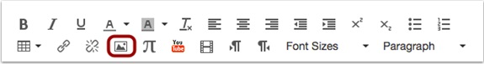
- Find the image to upload. Uploaded images are in the Canvas tab.
- In the Attributes section, add ALT text by replacing the image file name with a short description of the image.
- Click Update to complete the process.
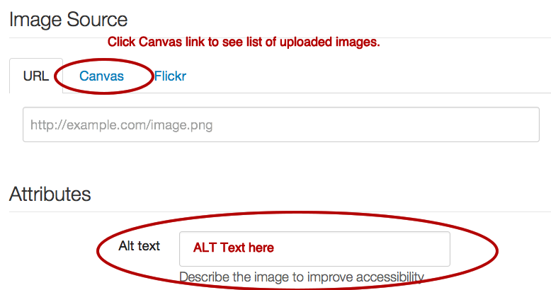

Applying Alt Text in MS Word and PowerPoint
You can add alt text to all images, objects, charts, and tables in Word and PowerPoint. To add alternate text to an image in either application, follow these steps:
- Upload or insert the image.
- Right-click on the image and click Format Picture.
- Click on the Layout & Properties icon (Labeled Size & Properties in PPT)
- Expand the Alt Text menu
- Add information in the title field. Add a description if the image needs more information to convey the meaning to a student who cannot see the image.
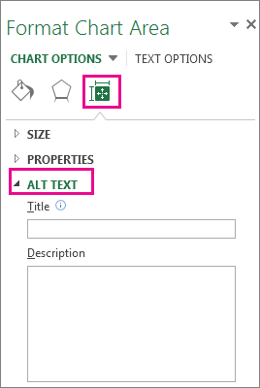

Closed-Captioning and Transcripts for Video and Audio
It is important to try to have closed captioning available on all videos in your course. Captions are ideal, but transcripts will also suffice if the audio does not correspond with actual visual content such as a demonstration. If you have a student in your class that has identified themselves as having a disability with our Center for Student Accommodation's office, we will need to provide equivalent alternative in a timely manner.

Faculty Created Videos
If you use VidGrid, Snagit, or any other screencapture tool to create a video, best practice is to make sure that closed captioning is available. VidGrid, a new tool launching at Pitt State in Spring 2019, will automatically create captions. YouTube will also automatically create captions for you if you publish your video to this site. However, they are not very accurate. As the owner of the video, you can edit these captions to correct errors. (Add subtitles & closed captions to YouTube.)

YouTube and Other 3rd-Party Videos
Try to choose videos that already have closed captions. Check the captioning for accuracy. If a video you choose to use for your course does not have CC or a transcript, here are some steps to take:
- Contact the owner of the video to see if they have a transcript or if there is a CC version available.
- If the video is on YouTube, contact the channel owner and see if he or she would be willing to turn on the crowd-sources captioning option. That would enable anyone to add captions.
- If you cannot obtain a transcript of CC-version of the video, communicate to students on day one of your class that a video or videos are not fully accessible. If a student needs accommodation, he or she should contact you immediately so that the university can quickly find a substitution for the video or provide some type service to make it accessible.

Audio Files
If you have audio files included in your course, a text transcript of the audio should be included to aid students with special auditory needs.

Recommended Design Practices

Font Styles and Size
You cannot choose different font families in Canvas, but in Word and PowerPoint these options are available. Here are some best practices regarding font and size selection.

Font Types
Best practice is to use no more than 2 font families. In Word and PowerPoint, use a design theme available in the product and you should be fine. Choose simple, clean fonts, not overly ornate, script fonts.

Font Size
Avoid using the "Font Sizes" option in the Canvas Rich Content Editor (RCE). Apply the paragraph and headers style options described earlier in this module. By using these tools, your end user can easily adjust the size of your content page by zooming in with their browser or other online tool to accommodate a visual disability.
In Word and PowerPoint, use the design theme and style tools. They will select appropriate font types and sizes.
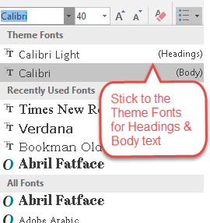

White Space, Color and Contrast

White Space
Never under estimate the power of white space or negative space. Large chunks of text should be broken up with ample white space. This will improve readability of your content. Again, using the text formatting options from the RCE in Canvas will help. Heading tags leave additional white space between it and the paragraph text. It can help reduce eye-fatigue for your learners.
A great way to describe the need for white space is a quote from the Interaction Design Foundations website. "People get frustrated when information bombards them. We’re humans, not machines. White space calms us, letting us “breathe”." (Interaction Design Foundation.)

Color
If you choose to use color do so meaningfully and don't create a rainbow of colored text! Color should enhance and not distract the reader. In Canvas, you can choose different text colors and different background (highlight) colors. If you highlight text you've created in Canvas, be consistent with the color applied. Also, color should not be the only tool used to convey information. If you want to emphasis text, the "bold" tool should be used alone or in conjunction with color.
Web Content Accessbility Guideline 1.4.1 states: "Color is not used as the only visual means of conveying information, indicating an action, prompting a response, or distinguishing a visual element."

Contrast
When using color, having ample contrast is key. All students will benefit by checking if your contrast is high enough. WebAIM (Web Accessibility in Mind) has some great tools to help you check contrast. Color Contrast Checker.
Below are some examples of Colors and Contrast Ratios within Canvas.
Poor Contrast: (under 4.5)
- Yellow Text:1.07:1
- Pale Green: Text 1.12:1
- Orange Text: 2.14:1
- Pink Text:3.14:1
Good Contrast: (4.5 to 7)
- Blue Text: 4.68:1
- Dark Green:5.14:1
- Purple Text: 6.95:1
Best Contrast: (Over 7)
- Burnt Orange: 7.43:1
- Very Dark Gray: 12.63:1
- Black text: 21:1

Sizing Images and Length of Videos

Images
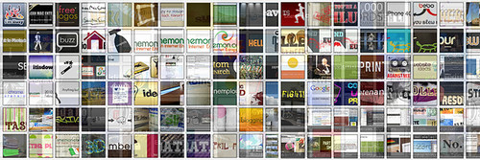
Best practice on sizing images is to make sure that viewing the image doesn't require scrolling if at all possible. If your original image is small, make sure not to enlarge it too much and lose quality.
Use the alignment tools in the RCE to align left, right or center. This image is embedded from Flickr and aligned to the right of this text. Re-size your browser to make sure the image displays the way you intend.

Video
QM recommends that long videos be "chunked" into smaller, 15-20 minute, videos. If you have captured full lectures, consider editing the videos into smaller chunks to improve student comprehension and to help overcome any technical issues. (QM Standard 8.5)

Testing on Different Devices/Screens
One very important test to run before publishing your course is to view your course on different size devices/screens. If you have an iPad, try opening your course with Safari or Chrome and open Student View mode. Also, on your mobile device, download and install the Canvas app and preview your course with it.
Consider different size monitors on laptops and desktop computers. To replicate how your course content adjusts to smaller screens, try re-sizing your browser window on a PC or Mac and see how your page content wraps when decreasing the size or how it looks stretched on a larger monitor.
The recommended maximum width for images and other graphic elements should be no more 640px, which is about 8.53 inches. For instance, if you create a banner for your course home page, make sure it is no wider than 8.5 inches so that the entire image can display as best as possible for your students.

Images in Canvas Mobile App
It is also a great idea to test what your content looks like from the Canvas mobile app. If you have a tablet or smartphone, download the Canvas Teacher app.
- Learn more about Canvas Teacher Mobile Apps

