This Job Aid walks through the process of entering a holiday on a time card. There are 3 examples to entering a holiday on a time card. Please be sure you use the correct example for your situation.

Example 1: If you DO NOT work on the holiday (See Steps 1-14)
Example 2: If you DO work on the holiday (See Steps 15-21)
Example 3: If you DO worked part of the day on the holiday. (See Steps 16-27)

Important:
- Hourly USS employees with benefits will use this job aid for Veteran’s Day.
- Hourly unclassified employees with benefits who do not work on Veteran’s Day will use the job aid “Veteran’s Day – Hourly Unclassified Employees,”

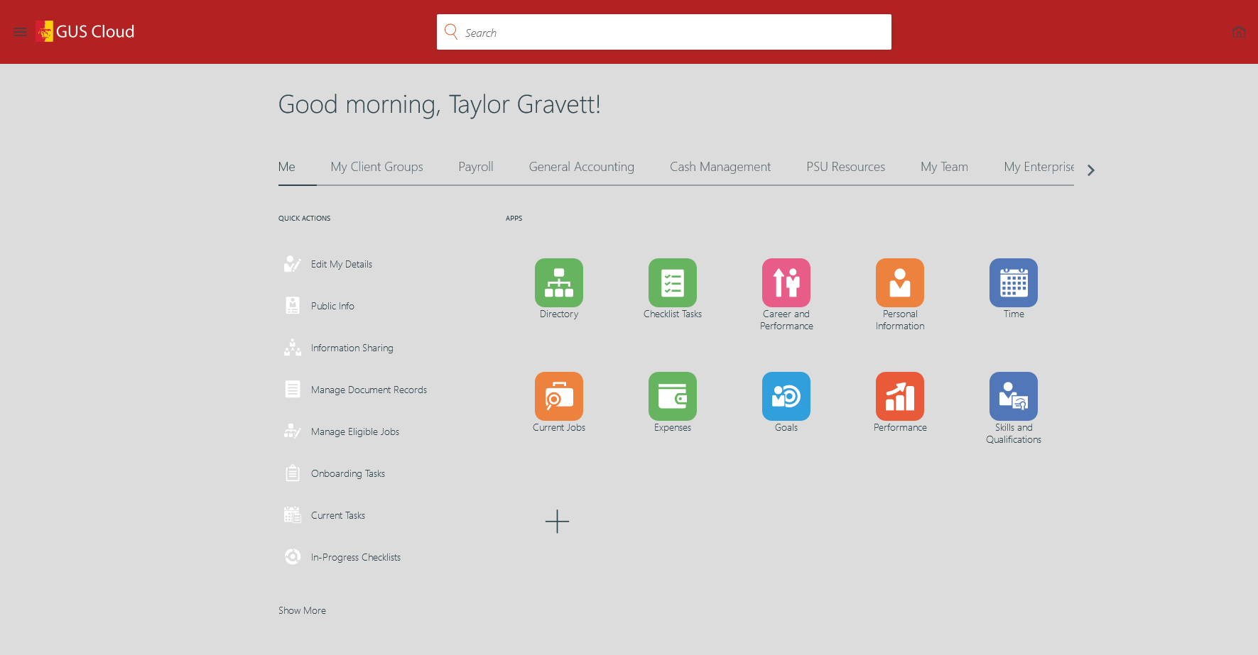

Step | Action
1. | Click Time. Note that the Time icon may also be found under the “Me” tab on the springboard page.  

2. | Example 1 – This is how to report time for a holiday if you DO NOT work on that day. This employee’s regular schedule is Monday through Friday 8 hours a day.  This pay period we have a holiday. In the calendar view you will see the holiday name listed. Even though it is listed it does not automatically pay you for that day. Click on a day of the week and drag Regular to that day.  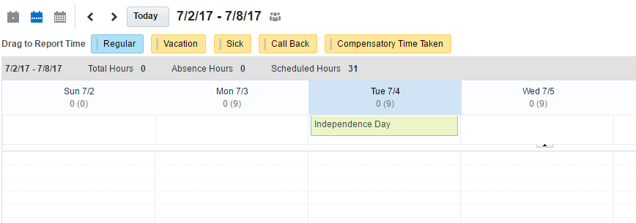
3. | Complete the report time dialog box. Select the Assignment Number and Position. Remember to select Overtime or Comp Time to match the other time types reported for the week. Verify the Start Date and End Date are correct. Input the daily hours. Click Save and Close.  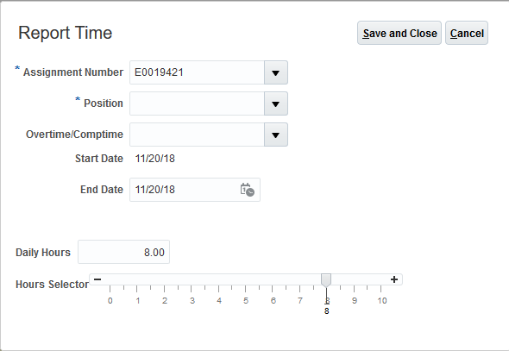
4. | Select Edit after completing one day of time.  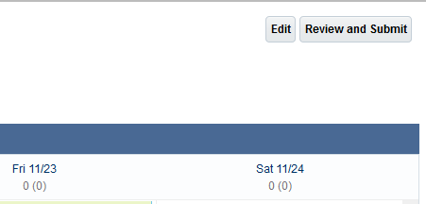
5. | Once you are at the Time Entry View you will select row 1 (click by the number 1). The row will appear BLUE.  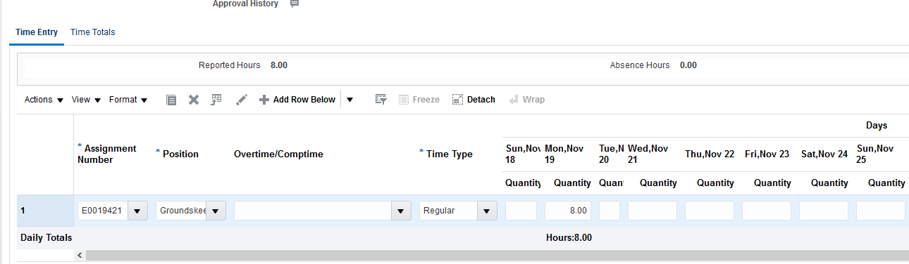
6. | Select + Add Row Below
7. | Select Assignment Number, Position, Overtime/Comptime and search Time Type for Holiday Credit.  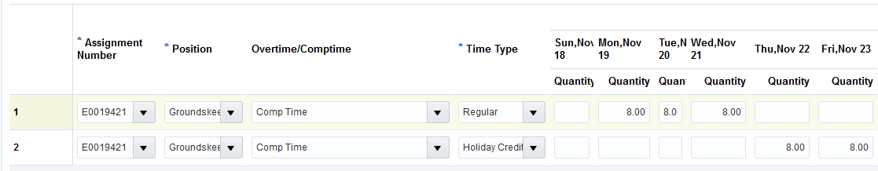
8. | Continue to fill out the rest of the time card with time worked and leave taken.  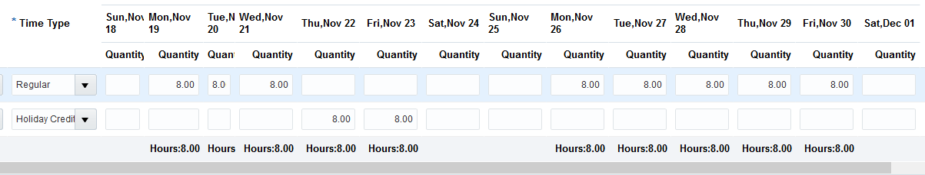
9. | Select Save  
10. | Select OK  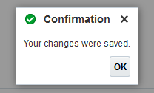
11. | Select Next
12. | Review Time Card Details.  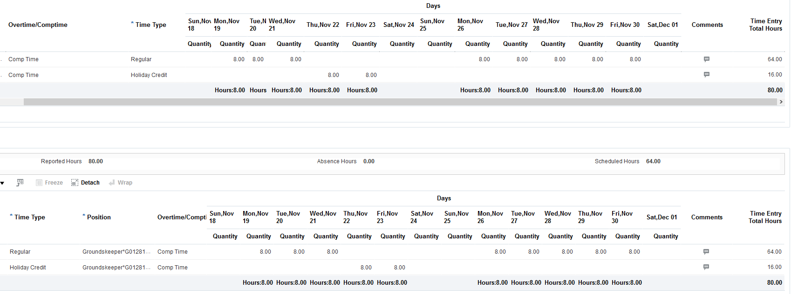
13. | If the information is correct, select Submit.  
14. | Select OK.  

15. | Example 2 – This is how to report time for a holiday if you DO work on that day. This employee’s regular schedule is Monday through Friday 8 hours a day.  This pay period we have a holiday. In the calendar view you will see the holiday name listed. Even though it is listed it does not automatically pay you for that day. Click on the day of the holiday above or below the holiday name.
16. | Complete the report time dialog box:  - Select the Assignment Number and Position.  - Select Regular if you did work on this day for the Time Type.  - Select Overtime if you want to receive overtime pay for working on the holiday or Comp time if you want to receive compensatory time hours for working on the holiday.  - Verify the Start Date and End Date are correct.  - Input the daily hours.  - Click Save and Close.  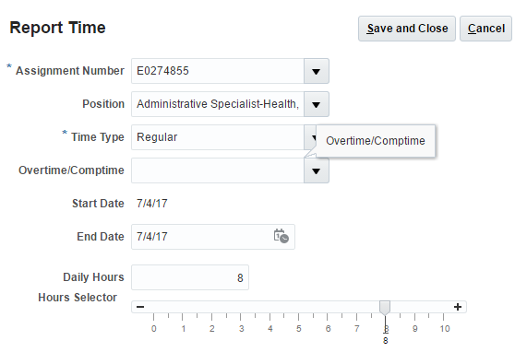
17. | Select Edit after completing one day of time.
18. | Continue to the time card view and fill out the rest of the time card with time worked and leave taken.  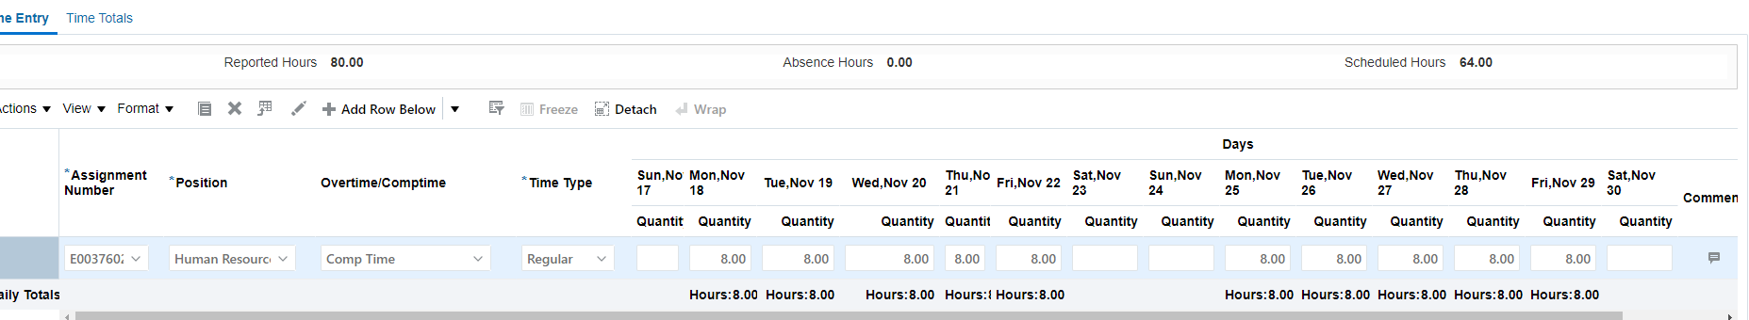
19. | Review Time Card Details.  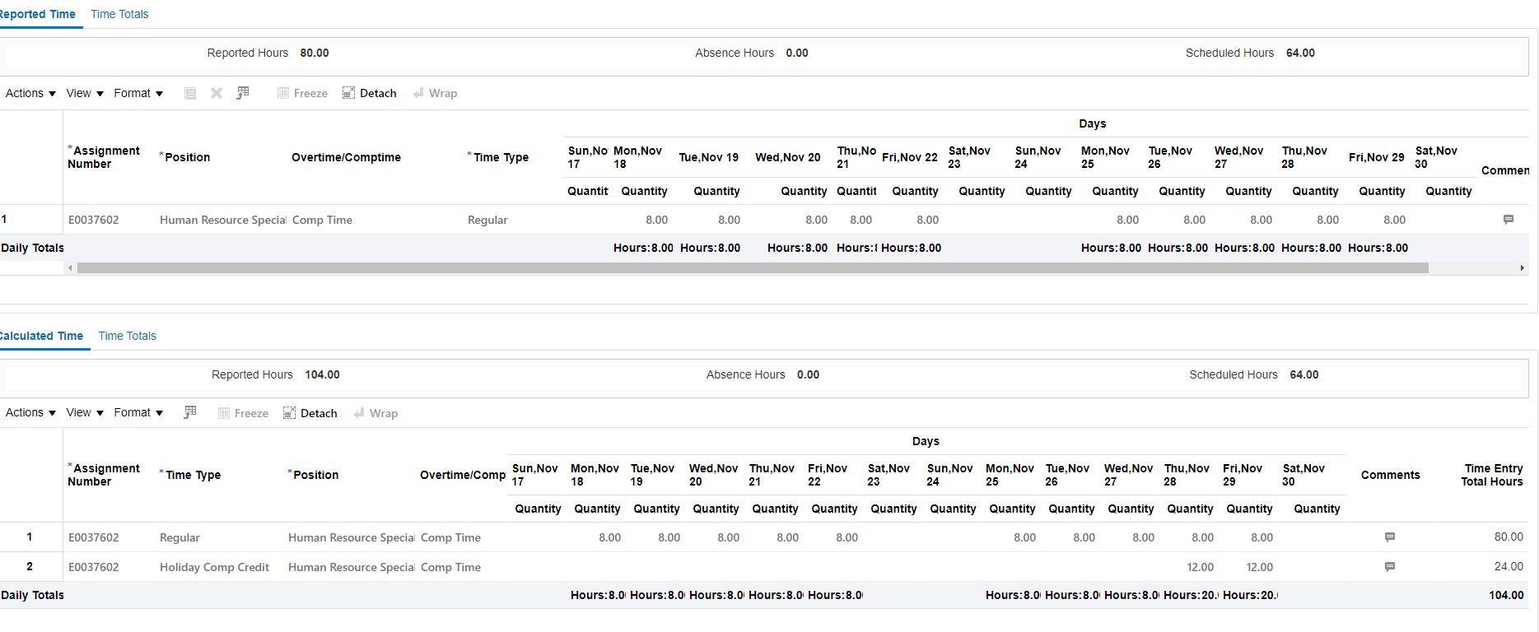
20. | If the information is correct, select Submit.
21. | Select OK.
22. | Example 3 – This is how to report time for a holiday if you DO work for part of that day. This employee’s regular schedule is Monday through Friday 8 hours a day.  This pay period we have a holiday. In the time card view you will see the holiday name listed. Even though it is listed it does not automatically pay you for that day. Click on the day of the holiday above or below the holiday name.
23. | Complete the report time dialog box:  - Select the Assignment Number and Position.  - Select Regular if you did work on this day for the Time Type.  - Select Overtime if you want to receive overtime pay for working on the holiday or Comp time if you want to receive compensatory time hours for working on the holiday.  - Verify the Start Date and End Date are correct.  - Input the daily hours. These are the hours actually worked.  - Click Save and Close.  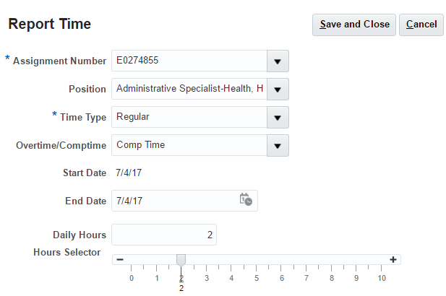

24. | Once you are at the Time Entry View you will select row 1 (click by the number 1). The row will appear BLUE.
25. | Select + Add Row Below
26. | Select Assignment Number, Position, Overtime/Comptime and search Time Type for Holiday Credit. Enter the Holiday Credit hours (i.e. 8 hours less 2 hours worked = 6 hours credit)  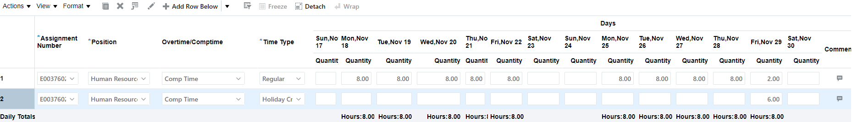
24. | Continue to the time card view and fill out the rest of the time card with time worked and leave taken.  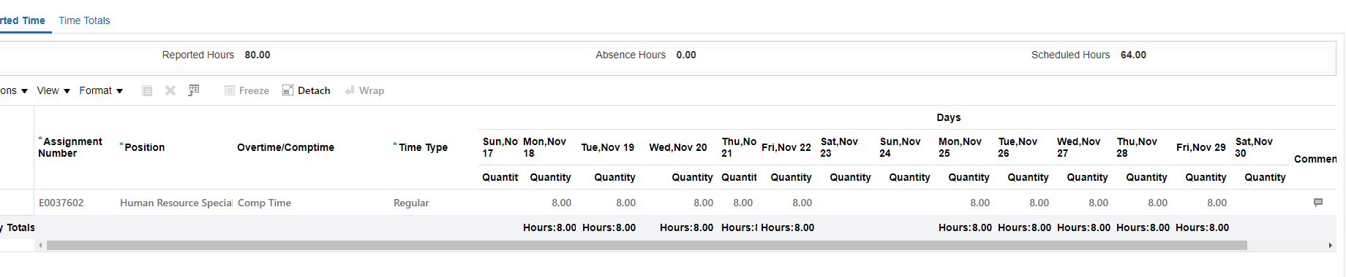
25. | Review Time Card Details. The system will add the hours of holiday credit as well as the hours of holiday comp earned.  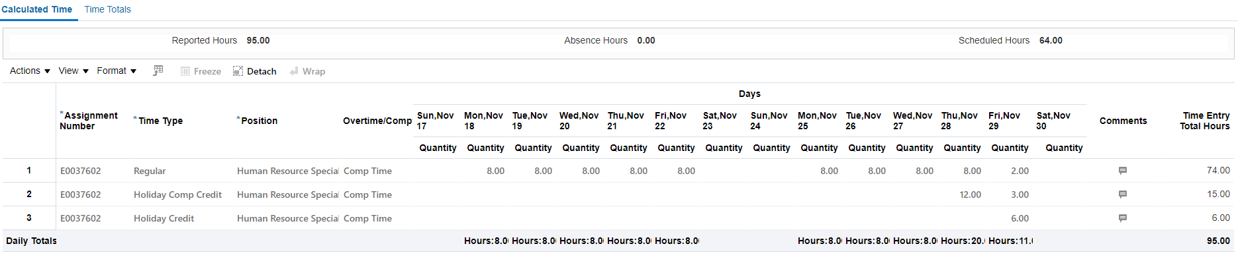
26.
  If the information is correct, select Submit.
  Select OK.

