PITTSBURG STATE UNIVERSITY
COLLEGE OF ARTS AND SCIENCES
DEPARTMENT OF BIOLOGY
GENERAL BIOLOGY [BIOL 111]
FALL 2018 SYLLABUS
Course Intended for Partial Fulfillment of the Pitt State Pathway Curriculum

Instructor: Dr. Andrew George (Face-to-Face section)
Email: adgeorge@pittstate.edu
Office hours: 322 Heckert-Wells Hall, Wed/Thur 1:00–2:00 or by appointment
Class hours: 213 Hughes Hall, MWF, 11:00 – 11:50

Instructor: Dr. Anuradha Ghosh (16 Weeks Online: Aug 21 - Dec 15, 2017)
Office: Heckert-Wells 321
Email: aghosh@pittstate.edu
Phone: 620-235-4532
Hours: 10AM – 12PM MTWThF (or by appointment)
PITT STATE PATHWAY
Mission Statement
The Pitt State Pathway curriculum serves as the heart of the university education by fostering interdisciplinary competencies that typify the educated person. It is designed to facilitate the development of key proficiencies including communication and information literacy. The Pitt State Pathway curriculum provides a transformational experience that challenges students to think creatively and critically, and to immerse themselves in the productive examination of humans in their global setting. By encouraging the development of skills that promote life-long learning, the Pitt State Pathway fosters a sense of personal responsibility, an appreciation of diversity, and an understanding of interconnectedness in our truly global society.
Pitt State Pathway Pillar to Be Covered in This Course
Global Understanding and Civic Engagement
As global citizens, students need a comprehensive understanding of where they live and of the larger, interconnected global system of which they are part, and on which they depend. While identifying commonalities among people and places is important, it is crucial that students understand and appreciate the diverse cultural, social, political, economic, and environmental contexts that create differences. Understanding the role of responsible citizens in their own community and beyond ensures effective and ethical participation at all levels. Students also need to understand how biological, physical, and chemical systems work, how they change naturally, and how they can change due to human involvement. Understanding the implications of the interaction between humans and non-human systems is essential for long-term decision-making.
Learning Outcome: Students will explore global systems conscientiously.
Pitt State Pathway Core Element to Be Covered in This Course
Quantitative/Analytic Methods
Quantitative literacy and its methods refer to competency in working with numerical data. Students with strong quantitative skills possess the ability to reason and solve problems from a wide array of contexts and everyday life situations. They can create sophisticated arguments supported by objective evidence and can communicate those arguments in a variety of formats (e.g. text, tables, graphs, mathematical equations, etc.) as appropriate. Competency in this element means:
- Applying a set of formal tools to interpret, represent, calculate, and analyze quantitative data;
- Explaining assumptions and rationale for selecting a mathematical approach to solve a problem;
- Explaining assumptions and rationale for selecting a mathematical or formal logical approach to solve a problem;
- Drawing and communicating conclusions to support decisions.

Pitt State Pathway Essential Element to Be Covered in This Course
Natural World within a Global Context
Biological, physical, and chemical systems form the context for life. Students need to understand how these systems work, how these change naturally, and how these can change as a result of human activities. The implications of these changes are essential for long-term decision-making. Competency in this element means:
- Analyzing biological, physical, and/or chemical systems;
- Evaluating the implications of changes that result from interactions between natural and human systems.

Pitt State Companion Element to Be Covered in This Course
Scientific Inquiry
The scientific method is the systematic approach to understanding the world around us. Through experimentation and hypothesis testing, students will apply analytical skills and appropriate methods of scientific inquiry (i.e. qualitative and quantitative) to solve a variety of research questions. Competency in this element means:
- Composing appropriate research questions and hypotheses, drawing from experts, reliable sources, or previously collected data;
- Collecting, synthesizing, and analyzing data from multiple sources;
- Drawing logical conclusions, assessing for gaps or weaknesses, and addressing potential consequences and implications;
- Communicating results using appropriate delivery methods or formats.

Course Description: Laboratory exercises to accompany BIOL 111 General Biology. In brief, the purpose of this laboratory course is to illustrate selected lecture topics in smaller group settings, provide opportunities for students to explore different applications of biology today, and encourage the life-long habit of examining current biological topics from several viewpoints.
Pre-requisite: None
Co-requisite: BIOL 112 General Biology Laboratory.
Course Learning Outcomes:

Core Element: Quantitative/Analytic Methods: Level of Student Learning: Milestone I
- Definition of Milestone I under Quantitative/Analytic Methods and Scientific Literacy: Students will apply tools of analysis and communicate results
Essential Studies Element: Natural World within a Global Context: Level of Student Learning: Milestone I
- Definition of Milestone I under Natural World within a Global Context: Students will explain biological, physical and/or chemical processes and human activities that alter them
Companion Element: Scientific Inquiry: Level of Student Learning: Milestone I
- Definition of Milestone I under Scientific Inquiry: Students will apply the scientific methods to a problem

After successful completion of this course, students will be able to…
- Apply the scientific methods to a problem.
- List the sequential steps to the scientific method, formulate a hypothesis, interpret data and produce viable conclusion based on the experimental results.
- List in order the steps in the hierarchy of biological system from an atom to an organism, compare and contrast the differences between four types of bonds, describe the properties of water and water chemistry.
- Identify the four major categories of macromolecules considered essential to life, discuss their characteristics and classification.
- Recognize the interrelationship of the various cellular organelles that maintain life, compare and contrast the differences between animal and plant cells.
- Explain the biological processes, such as photosynthesis, cellular respiration, and cell division; understand and explain genetic code and its application in transcription and translation by solving problems.
- Interpret the laws of passing traits from one generation to another, understand and explain Punnett square and pedigree-related problems, relate application of biotechnology in improvement of life.
- Illustrate the evolutionary line of organisms, list the characteristics and classification of plants and animals.
- Describe the characteristics of the various communities and ecosystems, explain survivorship curve and solve problems using Hardy-Weinberg formulas.
- Define and discuss the structural organization of animals at the level of tissues and organ systems such as digestive, circulatory, respiratory, immune, endocrine, reproductive, and nervous systems.
- Describe the structure, function, lifecycle, and physiology of flowering plants.

Method(s) of Assessment: (Online)
Assignments: Up to 4 concept papers and one physiology related final project
Quantitative/Analytic Methods: To assess the chosen level of student learning (Milestone I), the concept papers and the final project on Physiology will be to apply tools of analysis and communicate results.
Scientific Inquiry: To assess the chosen level of student learning (Milestone I), the concept papers and the final project on Physiology will be to apply the scientific method to assigned scientific problem.

Late submission policy: Up to 24h delayed submission of the Concept Papers will be considered with a 20% deduction. After that it is a zero. For quizzes, unit exams, and comprehensive final exam – assignments will NOT be available for submission after due date-time and automatically will be graded zero. Submissions will require MyLab and Mastering module on canvas if not stated otherwise. Up to 2 chapter quizzes can be re-taken if missed. Dynamic study modules can be re-taken as needed throughout the semester. None of the unit exams or final exam will be retaken. Graded discussions will be closed for comments on due date and will not consider any late participation.
Other assessments comprise of Chapter Quizzes, four Unit Exams, Dynamic Study Modules, Final Project on Physiology, Comprehensive Final Exam, and Graded Discussion Forums. Total possible points up to 700
Method(s) of Assessment: (Face-to-Face)
Assignments: Up to 5 reading assignments
Quantitative/Analytic Methods: To assess the chosen level of student learning (Milestone I), the reading assignments will be to apply tools of analysis and communicate results.
Scientific Inquiry: To assess the chosen level of student learning (Milestone I), the reading assignments will be to apply the scientific method to assigned scientific problem.

In addition to reading assignments, there will be four exams, weekly quizzes, and an optional comprehensive final exam can be taken to replace the lowest of the four regular exams. Total possible points 600.

Required textbook:
Face-to-Face: Campbell Essential Biology, by Simon et al., 5th edition, ISBN 9780321967671 + Modified Mastering Biology, ISBN 9780134040721

Online: Modified MasteringBiology with Pearson eText -- Standalone Access Card -- for Campbell Essential Biology (with Physiology chapters) (6th Edition). ISBN: 9780134040721. Selected chapters will be covered in this course.

Course Outline/Content:
Designed to acquaint the student with the fundamental principles and processes of life as found in animals and plants and their relation to the everyday life of humans.

Schedule of topics (Face-to-Face/Online): The following serves as a tentative outline, and may change slightly pending student interest in specific topics.

Dates  Aug 20, 22, 24 | Topic  Course Intro/Biology as a science | Chapter  1
Aug 27, 29, 31 | Molecules of Life/the Cell | 3, 4
Sep 5, 7 | Enzymes/Diffusion/Osmosis | 5
Sep 10, 12, 14* | Metabolism/Photosynthesis | 6, 7
Sep 17, 19, 21 | DNA/Cell division | 8
Sep 24, 26, 28 | Inheritance | 9
Oct 1, 3, 5 | Genetics/Biotechnology | 10, 12
Oct 8, 10* | Population genetics | 13
Oct 15, 17, 19 | Evolution of biodiversity | 14
Oct 22, 24, 26 | Microbes/Fungi | 15
Oct 29, 31, Nov 2 | Plants | 16
Nov 5, 7, 9* | Animals | 17
Nov 12, 14, 16 | Ecology intro | 18
Nov 19 | Biosphere | 18
Nov 26, 28, 30 | Populations | 19
Dec 3, 5, 7*  Dec 10* | Communities/ecosystems  Final Exam, Monday, 11:00 | 20
NOTE: * = Exam dates

Etiquette Expectations (Netiquette):
- Cell phones are not to be out during lecture or quizzes, except with instructor’s permission. Phones should be on silent/vibration upon entering the classroom. Laptops are allowed for note-taking unless they become distracting.
- It is expected that all students will communicate with one another and the professor in proper tone and civility, whether the communication is by electronic means, by phone, or face-to-face.
- E-mails are to be written in standard speaking style and not in popular abbreviations used online and/or using regional colloquialisms.
- Proper spelling and grammar are expected in communications with other students and the professor.
- Please be aware of and sensitive to all cultural differences of students and the professor when communicating.

Course and University Policies:

Academic Accommodations: Please see Center for Student Accommodations (CSA) if you are in need of any accommodations. http://www.pittstate.edu/office/center-for-student-accommodations/
CSA is responsible for ensuring that currently enrolled students with documented learning and physical disabilities are provided the tools, appropriate accommodations, and support from the University to fully participate in all aspects of campus life. Please click the link to the “Syllabus Supplement” for Fall 2018 semester for more detailed information.
https://www.pittstate.edu/registrar/syllabus-supplement.html
Dead Week Policy: As stated in the Syllabus Supplement regarding Dead Week Policy:
(https://www.pittstate.edu/registrar/_files/documents/syllabus-supplement-spring-2019-updated-10-5-18-.pdf) "no tests or major assignments will be presented during the week prior to final examination week, unless identified in the course syllabus presented at the start of the semester." For this class, the final exam will be presented during the finals week as stated in the tentative class schedule.
In addition, for this class, final points, the syllabus, assignments, due dates, exams, and/or quizzes may be changed accordingly throughout the semester as deemed necessary by the professor.

Attendance Policy: Students not attending class for the first two weeks will be dropped.
Formal attendance will not be taken. However, if you miss more than 4 assignments and do not have an excuse for them, will face the same consequences.

If you are absent due to illness, notify me via e-mail and provide a doctor’s note.

Academic Integrity Policy: Zero tolerance on cheating on quizzes or writing assignment.
http://www.pittstate.edu/audiences/current-students/policies/rights-and-responsibilities/academic-misconduct.dot This is the URL for more information on PSU policies concerning academic honesty and integrity.

Other information: Additional Information about courses, calendars, scheduling, etc. can be found at “Syllabus Supplement” for Fall 2018 semester: https://www.pittstate.edu/registrar/syllabus-supplement.html

Grading Policy (Face-to-Face): Student assessment will be based on four exams, weekly quizzes, and reading assignments. An optional comprehensive final exam can be taken to replace the lowest of the four regular exams.
Points
Exams (4) 400
Mastering Biology 100
Quizzes, readings, etc. 100

Total 600
Final grades will be determined on a standard scale, based on a total of 600 points possible (A = ≥ 90%, B = 80– 89%, C = 70–79%, D = 60–69%, F = < 60%).

Grading Policy (online):
Chapter Quizzes: 10 points each (Max. 20 quizzes = up to 200 points) – available online for two days – weighs 25% of total grade
Concept Papers: 5 points per chapter (up to total 100 points) – available online for one week – weighs 15% of total grade
Unit Exams: 50 points each (Max. 4 exams = up to 200 points) – available online for one day – weighs 40% of total grade
Dynamic Study Modules: 5 points per chapter (Max. 20 study modules = up to 100 points) – available online for 3-4 weeks – weighs 10% of total grade
Comprehensive Final Exam: 100 points – available online for two days – weighs 10% of total grade
Graded Discussion Forum: Points will be acquired based on individual participation
Total possible points = up to 700
There will be no traditional midterm exam. Grades will NOT be curved. Final grade will be determined based on cumulative points.

Grading Scale: A = 100-90%, B = 89-80%, C = 79-70%, D = 69-60%, F = 59% and below

Minimum Technology Requirements:
- Gorilla Geeks is a great resource for technical issues with Canvas, log ins, etc. They can be reached at the following: Gorilla Geeks Help Desk: 1.620.235.4600, E-mail: geeks@pittstate.edu, Web site: https://www.pittstate.edu/it/gorilla-geeks.html
- Most of you are new to the Leaning Management System (LMS) of Canvas. If you are not completely comfortable with Canvas please click the link to a Canvas help page: https://www.pittstate.edu/it/information-technology-services/canvas.html
- If you have technical questions, you can message the professor, use the Help menu the Canvas menu to the left, and/or contact Gorilla Geeks (see above for contact information).

Privacy Policies and Accessibility Statements for Third-Party Technologies
Below are links to privacy policies for several third party technologies that may be used in this online course.
Product | Privacy Policy
Adobe Products | http://www.adobe.com/privacy/policy.html
Canvas | https://www.canvaslms.com/policies/privacy
Google | https://www.google.com/policies/privacy/
Microsoft Products | https://privacy.microsoft.com/en-us/privacystatement/
Pearson Education | http://www.pearsoned.com/privacy-statement/
Respondus Products | https://www.respondus.com/about/privacy.shtml
Screencast-O-Matic | http://feedback.screencast-o-matic.com/tos
TechSmith Products | https://www.techsmith.com/privacy-policy.html
Turnitin | http://turnitin.com/en_us/about-us/privacy
YouTube | https://www.youtube.com/static?&template=privacy_guidelines

Example of assignments from concept papers and reading assignments: (These below qualify for Milestone I under Scientific Inquiry Rubric). These were not presented in the previous version of syllabus.

Molecular Genetics:

- Briefly describe how DNA is packaged to fit inside a cell

2. Describe what is meant by the antiparallel arrangement of DNA

3. On paper, replicate the following segment of DNA:
5’ ATCGGCTACGTTCAC 3’
3’ TAGCCGATGCAAGTG 5’

a) Show the direction of replication of the new strands and explain what the lagging and leading strands are.

b) Explain how this is semiconservative replication. Are the new strands identical to the original segment of DNA?

4. Explain the following relationship: DNA formats RNA, which makes proteins.

5. Explain how the leading or template is transcribed and translated into peptide
6. Compare the structure and functions of DNA and RNA.

8. Compare and contrast the actions of DNA and RNA polymerase.

9. What are the functions of start and stop codons? Give examples of them.

Genetic Inheritance:

Directions: Complete the following Punnett Squares. Be sure that you include the ratios of the genotypes (and the words used to describe those alleles) and phenotypes of the characteristics. Explain the ratios in terms of inheritance. (Need calculations)

1. B= Brown eyes b= blue eyes Mom= Bb Dad= BB What are the eye color possibilities if they chose to have children?
Genotypes Phenotypes

2. Curly hair is recessive, and straight hair is dominant. A woman with curly hair marries a man who is homozygous dominant for straight hair. Predict the outcomes for their children.
Genotypes Phenotypes

3. Black hair is homozygous dominant. Brown hair is heterozygous. Blonde hair is homozygous recessive. (This is an example of incomplete dominance.) A woman with brown hair marries a man with brown hair. What are the possible outcomes for their kids?
Genotypes Phenotypes

4. Attached earlobes are dominant over free hanging earlobes. Complete the Punnett Square for the following individuals: Mom=BB and Dad=bb
Genotypes Phenotypes

5. Incomplete dominance problem: T=tall (5’11”-6’2”); Tt=medium height (5’4”-5’10”)
t=short (5’3” or smaller)
Mom= 5’5”
Dad= 6’0” What are the possible height outcomes of their children?
Genotypes Phenotypes

6. Freckles are recessive. No freckles are dominant.
Mom= heterozygous Dad=homozygous recessive Possible outcomes for kids?
Genotypes Phenotypes

Pedigree Analysis
One application of Mendel’s Laws can be seen in the study of pedigrees. A pedigree is a graphic method of presenting the inheritance of particular traits in a group of related individuals. Males are represented by square symbols, and females are represented by circles. The trait of interest is indicated by a shaded symbol.
Consider the pedigree in the figure below, showing the inheritance of freckles. How is this pedigree interpreted? First, look at Row 1. Neither individual has freckles (both symbols are not shaded). Their son (Row 2) also lacks freckles, but he married a woman who has freckles (note the shaded symbol). The son and his wife have three children and two of them (a boy and a girl) have freckles.

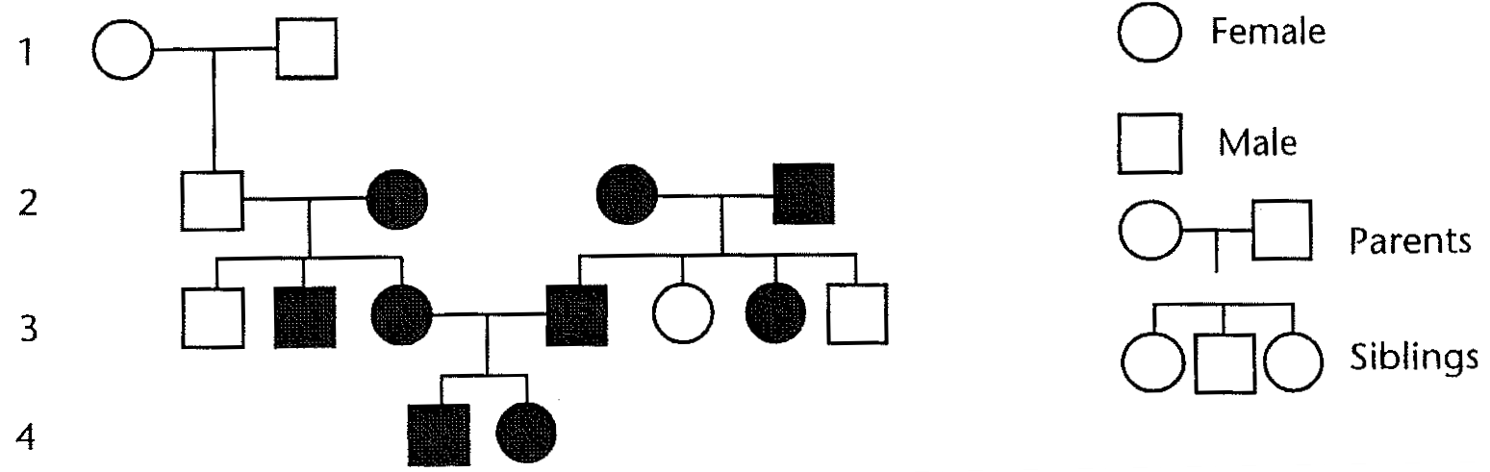

Explain in detail how can we tell whether freckles is dominant or recessive? Look at the second family (starting on the right half of Row 2). Both of these individuals have freckles. This tells us freckles must be dominant. If freckles were recessive, then the two freckled parents in Row 2 could not produce any children without freckles. On the other hand, if freckles were dominant, then the two freckled parents in Row 2 could produce children without freckles. (Explain how? If the freckled parents were heterozygous, then they would have freckles, but they could also contribute the recessive allele to an offspring. If both were heterozygotes, a homozygous recessive child is possible.)
Now that we know that freckles is dominant, it is possible to examine genotypes for individuals in Row 3.
- What genotypes would result in the freckle phenotype?
- Can the parents in Row 2 produce either of these genotypes?
- Can you state with certainty the genotypes of the two freckled individuals who mate in Row 3?
- What are the possible genotypes of the individuals in Row 4? Can you state their genotypes with certainty?

Population Dynamics
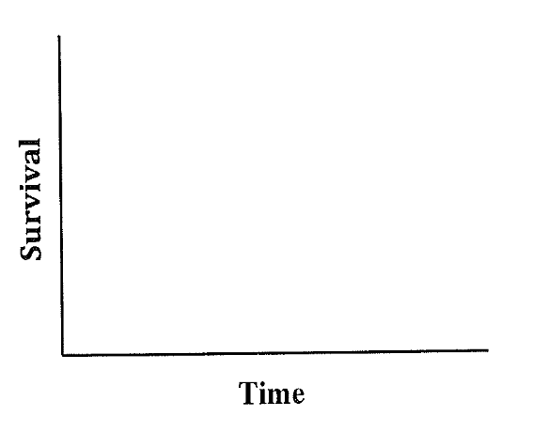
- Giraffes exist in relatively stable populations where the adults produce few offspring and provide high levels of parental care. In the figure to the right, draw the survivorship curve that you would expect for giraffes and explain the curve.

- In a population of Pacific Chorus Frogs that is in Hardy-Weinberg equilibrium, there are 168 green individuals and 32 gray individuals. If green is dominant to gray, what is the frequency of the recessive allele in this population? (Need calculations)

- In eastern scarab beetles, spots are dominant to no spots. Assuming that the following population of beetles is in Hardy-Weinberg equilibrium, how many beetles are carriers for the no spots allele? (Need calculations)
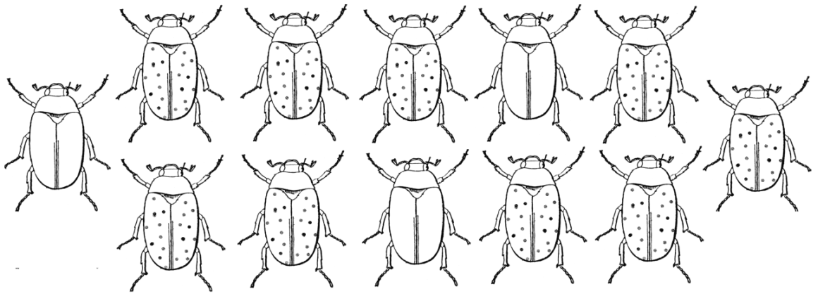

Example course and module objectives and assessment

Course Learning Objective # | Module Title | Module Learning Objectives | Learning Activities | Measurement (all graded activity)
1, 2, 3, 4 | Module 1: Chapter 1 | 1.1 Compare discovery science and hypothesis-driven science. Provide examples of each. | Read chapter 1 (refer to e-textbook) | Complete Ch 1 MCQ quiz on MyLab&Mastering
 |  | 1.2 Distinguish between a hypothesis and a theory. Explain why natural selection qualifies as a scientific theory. | View related lecture ppt and animations uploaded on canvas module 1 | Complete concept paper related to Ch 1 on MyLab&Mastering
 |  | 1.3 Describe seven properties or processes we associate with life. | Complete Ch 1 dynamic study module on MyLab&Mastering | Complete unit test 1
 |  | 1.4 Distinguish between the three domains and four eukaryotic kingdoms of life. | Comment on muddiest point forum created in module 1 on canvas
 |  | 1.5 Compare and contrast artificial and natural selection.
 |  | 1.6 Identify and explain information flow and how it functions to regulate processes within biological systems.
 |  | 1.7 List and give an example of each level of biological organization, starting with an ecosystem and ending with atoms.

Example assignment: Project papers on Physiology (10 points)

Chapter 22: Nutrition and Digestion

Guided Reading Activities

Chapter Content: An Overview of Animal Nutrition
Complete the following questions as you read the chapter content—An Overview of Animal Nutrition:

- List an herbivore, carnivore, and omnivore from where you live.

- List the four stages of food processing in order from beginning to end: absorption, ingestion, elimination, and digestion.

1.

2.

3.

4.

- True or false: Even though the protein in a drumstick is nearly the same as the protein in your leg, your body still breaks the protein down into small molecules. If false, make it a true statement.

- What does the chemical digestion of fats, carbohydrates, and proteins require? Hint—there are two elements required.

Protein

H2O









Amino acid












OH
H

Enzyme (pepsin)

Carbohydrate

H2O


Sugar
H


OH




Enzyme (amylase)

Fat







H2O
Fatty acid
Glycerol


H2O
H2O
Enzyme (lipase)




- How does a gastrovascular cavity differ from an alimentary canal?

Chapter Content: A Tour of the Human Digestive System
Complete the following questions as you read the chapter content—A Tour of the Human Digestive System:

- In a manufacturing assembly line, products get larger and more complete as they move along. Briefly explain how this process compares to your digestive system.

- The long, hollow tube of your digestive system is called the .

- Place the following organs in order with respect to their location along your digestive tract: pharynx, anus, stomach, mouth, and small intestine.

1.

2.

3.

4.

5.

- Digestion begins as soon as food hits your mouth. Briefly explain the two kinds of digestion that occur inside your mouth.

- is the rhythmic contractions of the digestive tract that moves food to your stomach.

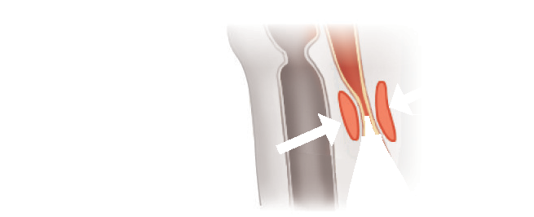





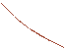










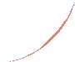



































































































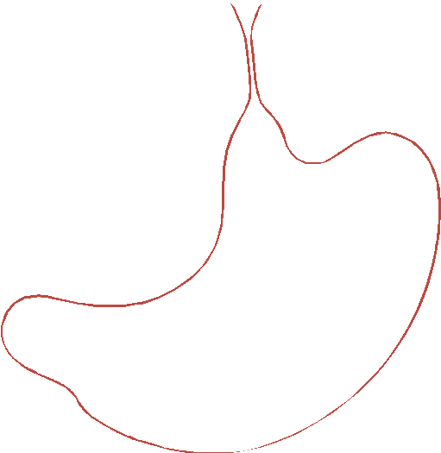






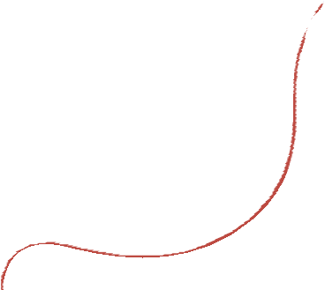







































Esophageal sphincter (contracted)

Food ball Relaxed muscles

Contracted muscles Relaxed muscles

Stomach

- What structure closes off the trachea during the swallowing of a ball of food?

  - esophagus

  - epiglottis

  - esophageal sphincter

  - larynx

- Briefly explain why the term “heartburn” is inaccurate.

- Digestion occurs in which region of the small intestine?

  - jejunum

  - duodenum

  - ileum

  - gall bladder

- The small intestine primarily absorbs , while the large intestine primar- ily absorbs .

Chapter Content: Human Nutritional Requirements
Complete the following questions as you read the chapter content—Human Nutritional Requirements:

- is the form of energy that your cells require to perform their func- tions. This form of energy is made in the , in a process known as
.

- Briefly explain the relationship between a calorie and a kilocalorie.

- True or false: Essential nutrients are substances that the cells of your body cannot make them- selves. If false, make it a true statement.

- The major difference between vitamins and minerals is that vitamins are , whereas minerals are .

- A common misconception about vitamins is that you can never have too much of a good thing. Briefly explain why this is an incorrect way of thinking with respect to vitamins. Your answer should include at least one example of what happens when you get too much of a vitamin.

- How many slices of bread would you have to consume in order to meet your daily requirement of calories? Assume you have an 1,800 calorie a day diet.

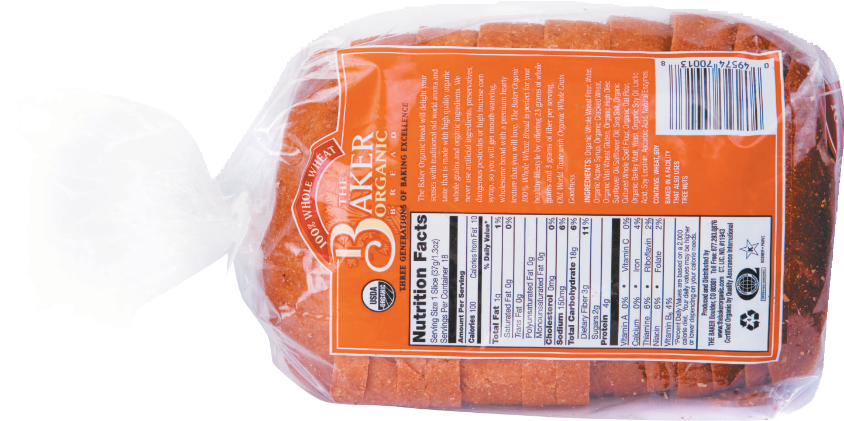
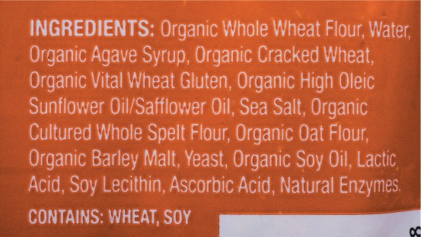
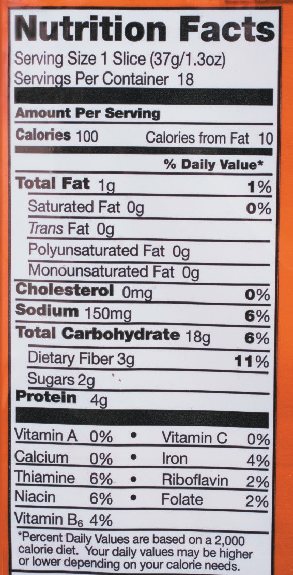

Chapter Content: Nutritional Disorders
Complete the following questions as you read the chapter content—Nutritional Disorders:

- Nutritional deficiency due to insufficient intake or a medical problem is known as .
Height

- Explain how eating disorders like bulimia and anorexia lead to malnutrition.

- People in developing worlds often get too little in their diets.

  - protein

  - carbohydrates

  - fat

  - sugar

- is having a that is too high, which is a ratio of your weight to height.

- You are 6’1”. According to the BMI table, what is your ideal weight range?

6’4”
6’3”
6’2”
6’1”
6’0”
5’11”
5’10”
5’9”
5’8”
5’7”
5’6”
5’5”
5’4”
5’3”
5’2”
5’1”
5’0”
4’11”
4’10”
100 110 120 130 140 150 160 170 180 190 200 210 220 230 240 250 260
Weight (pounds)

Major Theme Connection:
1. You just ate a bowl of mashed potatoes. The starch began chemical digestion in your mouth and finished in your duodenum with hydrolysis into glucose molecules. The fate of the starch is conversion to glycogen in your liver. What did the glucose travel through in order to get to your liver?

Common Thread Connection:
1. What was the effect of leptin injections on mice that were leptin deficient due to a defective gene?

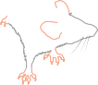

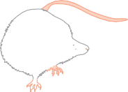








Mutant mice with
defective obese gene

Mice with normal
obese gene
0102030405060
Ending body mass (g)
Injected
with saline
Injected
with leptin

List of assignments


