College of Technology Open House and Career Expo*
For High School and Tech School Students
Audience: | High School/Tech School Students Grades 10-12, counselors, administrators, and parents
When: | Friday, March 1, 2024
Recommended Time: | 8:00 AM – Noon
Where: | Kansas Technology Center, Pittsburg State University  909 E. Ford Ave. Pittsburg, Kansas, 66762
Registration/FMI: | https://www.pittstate.edu/ktcopenhouse

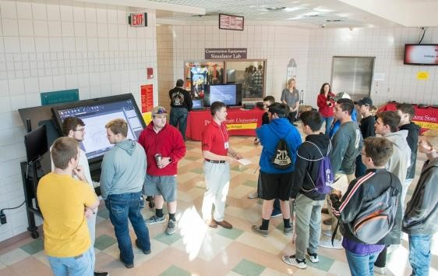
Schedule:
- Check-in between 8:00 AM and 10:30 AM
- 20-minute orientation tour to KTC, followed by---
- Open Schedule of Investigative Activities, including:
  - Dozens of Demonstrations. Provided in at least 12 different technology venues; see or operate equipment; simulators; displays
  - Hands-on opportunities. Experience emerging technologies & take-home items made
  - Interactions. Discuss career opportunities, PSU and internship experiences with students and faculty, and alumni company reps
  - Door Prizes. Prizes/scholarship vouchers available
  - Information Station Highlights. Careers in STEM; Scholarship Opportunities; Military Options; Student Organizations and Special Events; and Information about Pitt State
- Noon – Event Ends/Remaining Buses Leave

* Virtual Open House event is also available at your convenience February 2 – March 8, 2024, if face-to-face visit is not feasible. ALL registered students are provided access to virtual site. Opportunities for SCHOLARSHIPS earned by completing “virtual site” Feedback Sheets.

