Report on the Requirement of 54-hours of Upper-level Courses for Baccalaureate Degrees
Council of Faculty Senate Presidents
14 March 2002

Current Practices
For many years, the six state universities in Kansas have used guidelines for program approval, which require a minimum of 40 hours of upper division course work (those courses numbered 300 and above), with no more than 60 hours transferrable from a 2-year institution (courses numbered 100-200). Some exceptions to this rule were allowed and approved by the Board. In addition, some exceptions were allowed for individual students upon a ruling by exceptions committees at each institution.

Across the six state universities, 120-124 hours are required for graduation (8 semesters of approximately 15 hours each). Considering the 40/60-split and the number of hours required for graduation, currently 10-25 hours of the total hours, depending upon the major, can be used to take additional electives within a student’s major or minor (allowing for increased depth) or can be used for exploration (allowing for breadth). Most students take more than the required 120-124 hours for graduation. These additional hours are taken by choice or as a result of meeting different requirements caused by transferring majors, colleges, or universities.

New Policy
In the fall of 2001, the Board of Regents raised the number of hours required for programs at 4-year institutions from 40 to 54, based on information from the six state universities that the average undergraduate student already graduates with more than 54 hours of upper division hours.

Curricular Implications
As the degrees are currently constituted, many degrees and programs at the six state universities do not meet 54-hour requirement (Table 1.) This means that after subtracting the required lower level hours from the total required to graduate (120 to 124) there are fewer than 54 hours remaining with which to meet the 54-hour requirement. Many programs can be made to meet the 54-hour requirement while not increasing the number of hours for graduation. These accommodations can be made in a variety of ways: (1) reexamining general education requirements, (2) requiring additional upper level courses, (3) renumbering some courses, or 4) removing some lower level requirements.
Table 1. Currently established programs that do not meet the 54-hour requirement.
Institution | Number of programs  including concentrations within majors | Number of programs not meeting the 54-hour requirement | Percent not meeting the requirement
Emporia State University | 98 | 29 | 30%
Fort Hays State University | 131 | 101 | 77%
Kansas State University | 197 | 119 | 60%

Pittsburg State University | 108 | 66 | 61%
Wichita State University | 113 | 79 | 70%

The programs that are going to have the greatest difficulty accommodating the requirement are some Bachelor of Science (BS) degrees in the sciences and most of the Bachelor of Arts (BA) and Bachelor of Fine Arts (BFA) degrees. The philosophy behind the BA, rather than the BS, is for the student to have a broad background as represented by general education courses, to have a specialization in one specific field of study, and to have another ancillary area of study. The general education portion of the course work is primarily at the 100 and 200-level, the area of specialization also requires several 100 or 200 prerequisites to the upper level courses within the major. The second field of study also typically contains several 100 and 200 level courses as prerequisites for the more advanced courses. Thus the BA degree has many hours (often close to 80 hours) of required lower level courses. The general education requirements are typically taken at either a community college or four-year institution. However, the strict prerequisites are part of a well-integrated cohesive curriculum and are most often taken at the four-year institution. To require 54 hours of upper level courses within the present structure of these programs would likely increase the number of hours required for graduation.

Conceptually, the BA degrees at the state universities require 10-16 hours of foreign language courses, all taken at the 100 and 200 level. To progress to upper level courses in foreign language, a student must take additional hours. Thus, for a student to take both a foreign language and to meet the 54-hour requirement, again requires the student to take additional hours

Some BS degrees, especially those in the sciences, require introductory level courses in several disciplines. For example, degrees in Chemistry require 20 or more hours of introductory courses in physics and mathematics. This and this leaves little to no room for additional upper-level courses within the limit of 124 hours.

The 54-hour rule in the Bachelors in Fine Arts also presents problems. For example, music degrees at all six state universities require about 16 hours of introductory music theory courses. Recently, the chairs of the music departments have been meeting with their accrediting agency, because faculty in music departments fear that the accrediting agencies will not appreciate the necessary restructuring of the curriculum to meet the 54-hour requirement.

Implications for Students
Requiring 54 hours of upper-division work will also produce the following system-wide challenges or effects for students.

The imposed 54-hours will have a negative effect on a liberal arts education. A broad preparation base, such as presently advocated in the general education programs is necessary for students to prepare for a changing society. This breadth of preparation allows graduates to have a fluidity in career choice as the market and job needs change.

Presently, students who graduate with the minimum number of hours required for graduation average many fewer hours than 54 hours of upper division coursework. For example, at ESU, for spring 2001 graduates, the average number of upper-level hours is greatly inflated by students who have many more than the required 124 hours to graduate (Figure 1). Similar patterns are observed at the other Regents universities. It should be noted that a student who takes 140 hours or more often does this as a choice, perhaps to take additional courses they want to take, a choice to have two majors, because of increased hours required by a professional program, or to change majors several times. By having 140 hours, a student elects to add a semester or two to their college experience. If we are to keep the college experience to a nominal four-year degree, then it is important not to add additional course work to the 120 to 124 that is already required.

Students and their advisors will have to be much more careful when choosing electives. In almost every case, the options that students had will now be narrowed. The effect will be to compel students to take additional courses within the major for which they have already taken the introductory courses, rather than exploring a second area of interest that would necessitate taking additional introductory courses.
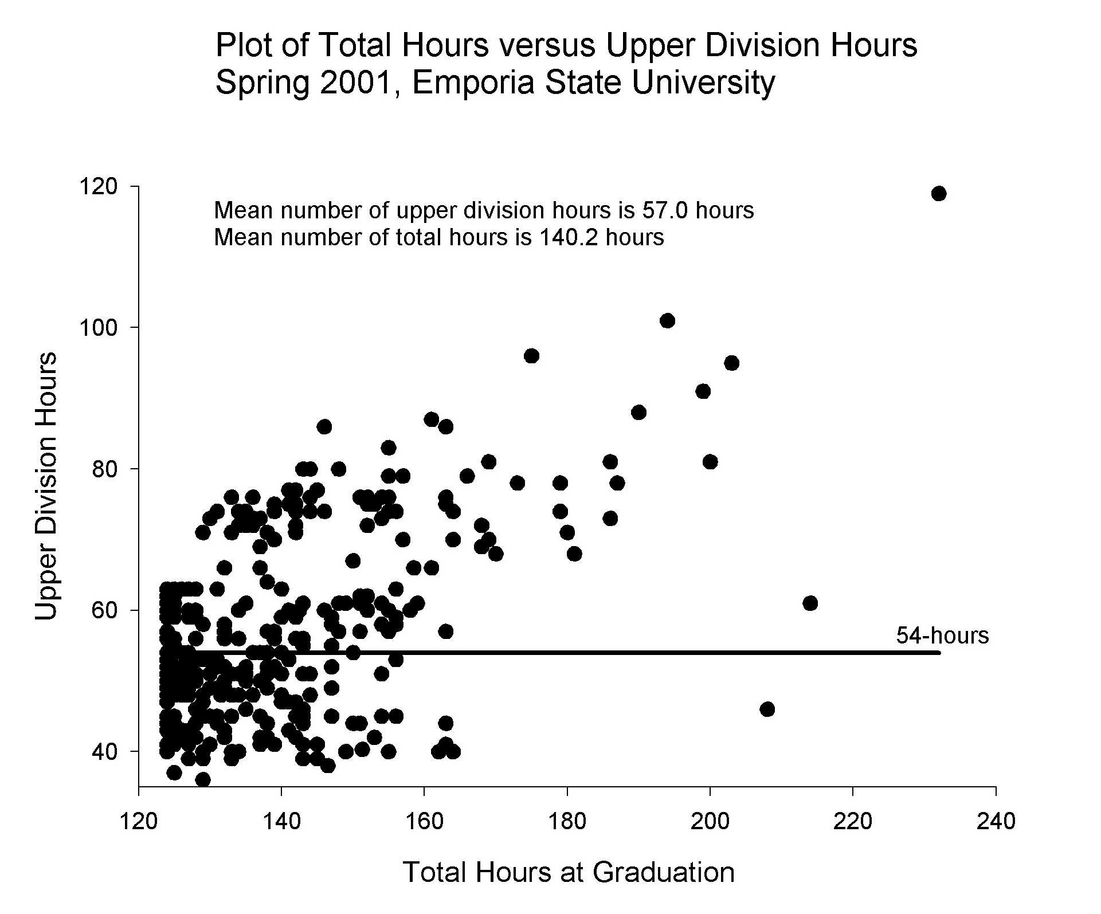

Figure 1. Plot of total hours at graduation versus upper division hours for the 340 graduates for the spring 2001 semester at Emporia State University.

Implications for Community College Transfers
Depending upon how state universities meet the 54-hour rule, transfer of course work from community colleges to the state universities may be affected. For example, a course taught at a community college as a lower level course and taught at one of the state universities as an upper level would transfer to the four-year institution has having met the requirement of the course but would not be counted in the 54 hours of upper level courses required for graduation.

Without careful advising, transfer students may have to take additional hours to meet the 54-hour requirement. Community college students with AA or AS degrees who have already graduated, been in the workforce, and now seek transfer, will most likely lengthen their degree requirements unless they had carefully planned their lower division course work. If students have not taken the foreign language requirement at the community college, they could have as many as 79 total hours of lower division credit. With the additional 54 hours of upper division credit, student would graduate with a minimum 133 hours rather than the traditional 124.

A specific analysis by the faculty at Fort Hays State University indicates that if 13 courses in the general education program were moved from lower division to upper division courses, transfer students would be seriously affected. This move equates to 39 hours of credit that can no longer be taken at a community college for transfer credit. Additional time would be needed to make up the upper level general education course work and meet the 54-hour course minimum. This being the case, with the implementation of the 54-hour rule, students would be dissuaded from starting their education at a community college.

Additional Influences
A survey of the peer institutions for the regional universities shows that none require more than the equivalent of 40 hours of upper level course work (Table 2).

Table 2. Degree requirements for the peer institutions of the regional universities.
Institution and degree | hours for degree |  |  | upper level requirement
Northwest Missouri State  BA | 124 | 32
Northwest Missouri State  BFA, BS, BSE | 124 | 40
Salisbury State University | 120 | 30
Northern Michigan University | 124 | no requirement
Western Carolina University | 120 to 128 | 32 (25% of the total)
Eastern Washington University  (uses the quarter system) | 180 | 60

A survey of universities in the Big 12 shows that none require more than 48 (Table 3). Across all universities the average number of required upper-level hours is 38 while the average total hours required for graduation is 123. Fifty four hours of upper-level courses will put the state universities in Kansas in the very highest category and out of line with other institutions of higher education. This will likely decrease the number of out-of-state transfer students to the universities of Kansas.

Table 3. Degree requirements for universities in the Big 12.
Institution and degree | hours for degree | upper level requirement
Baylor University | 124 |  |  | 36
Iowa State University | 124.5 |  |  | 45
Oklahoma State University | 127 |  |  | 48
Texas A&M University | 128 |  |  | 36
Texas Tech University | 125 |  |  | 40
University of Colorado | 120 |  |  | 45
University of Missouri | 120 |  |  | 30
University of Nebraska | 125 |  |  | 30
University of Oklahoma | 124 |  |  | 48
University of Oregon | 120 |  |  | 41
University of Texas | 120 |  |  | 36

The one-year time frame to complete this process presents a challenge for review and communication of the changes that will occur. Degree redesign and curriculum changes will be required in some majors. These changes will require work by the faculty; curriculum change forms to be processed through departments, colleges, and institutions; publication and dissemination of new program requirements; and redoing all articulation agreements between each institution and all community colleges. Without adequate time to notify students of impending changes to their programs, increased costs caused by the increased number of hours might discourage their attendance at state universities.

Summary
In summary, this rule potentially forces students away from lower level introductory courses and into more advanced courses within the student’s already chosen major, limits the foreign language requirements at all of the universities at a time that our increasingly global society requires speaking more than one language, narrows the breadth of a student's education, and increases the specialization in a student's program. In addition, the 54-hour rule could have detrimental effects on students who transfer from community colleges or other universities into Regents universities causing revamping of all articulation agreements and course equivalencies. The 54-hour requirement will make the changing of majors or being undecided more problematic, leading to advising difficulties.

COFSP Proposal
Our proposal would be to establish the rule of 60 hours from a 4-year institution and 45 hours of upper level courses be required for the baccalaureate. This proposal will also allow a student to complete two years of education at a community college (the general education component plus a little—up to 64 hours). The final two years would occur at a 4-year institution where the student would complete the major requirements including both lower level prerequisites and cognate courses and then the upper level courses in the field(s) of study specific to the programs.

Minority Position
At WSU the 54-hour standard is already met or can be easily met by many of our programs. The General Education program already allows for further study and upper level seminars. Thus, for native students (those who complete all four years with us), potentially 1/2 of our programs already meet the 54-hour standard. For a few, minor changes will be required. For others, it will be more difficult to meet and major curriculum changes will be necessary. However, even in those cases, there is a sense among the WSU faculty that this standard will strengthen their degrees.

Respectfully Submitted,

Dwight Moore, Chair - Emporia State University
Paul Adams - Fort Hays State University
Cia Verschelden - Kansas State University
Tom Beisecker - Kansas University
Bill Barkman - Kansas University Medical Center
Khamis Siam - Pittsbug State University
Jeri Carroll - Wichita State University

